**Title:** Carbon cycling in mature and regrowth forests globally: a macroecological synthesis based on the global Forest Carbon (ForC) database

**Authors:**

Kristina J. Anderson-Teixeira1,2*

Valentine Herrmann1

Becky Banbury Morgan3

Ben Bond-Lamberty4

Susan C. Cook-Patton5

Abigail E. Ferson1,6

Jennifer C. McGarvey1

Helene C. Muller-Landau1

Maria M. H. Wang1,7

**Author Affiliations:**

1. Conservation Ecology Center; Smithsonian Conservation Biology Institute; National Zoological Park, Front Royal, VA 22630, USA
2. Center for Tropical Forest Science-Forest Global Earth Observatory; Smithsonian Tropical Research Institute; Panama, Republic of Panama
3. School of Geography, University of Leeds, Leeds, UK
4. Joint Global Change Research Institute, Pacific Northwest National Laboratory, College Park Maryland 20740, USA
5. The Nature Conservancy; Arlington VA 22203, USA
6. College of Natural Resources, University of Idaho; Moscow, Idaho 83843, USA
7. Grantham Centre for Sustainable Futures and Department of Animal and Plant Sciences, University of Sheffield, Western Bank, Sheffield, South Yorkshire S10 2TN, UK

*corresponding author: [teixeirak@si.edu](mailto:teixeirak@si.edu); +1 540 635 6546

## [1] 0

*NOTES TO COAUTHORS:*

* We’re still finalizing the data (and adding some data). Outliers in plots will all be checked/ resolved, and we’ll be able to pull in more data (*GROA* needs classification by dominant vegetation before it can be pulled in, and we’re working on that)
* “**???**” indicates a reference that we have entered in the .Rmd file, but not yet in the bibliography file. Don’t worry about those. (However, places with “REF” need references)
* bold/ italic text indicates places where I know we need to go back and revisit/ fill in info

## Summary

*Background.* Earth’s climate is closely linked to forests, which strongly influence atmospheric carbon dioxide (CO2) and climate by their impact on the global carbon (C) cycle. However, efforts to incorporate forests into climate models and CO2 accounting frameworks have been constrained by a lack of accessible, global-scale data on how C cycling varies across forest types and stand ages.

*Methods/Design.* Here, we draw from the Global Forest Carbon Database, ForC, to provide a macroscopic overview of C cycling in the world’s forests, giving special attention to stand age-related variation. Specifically, we use 14847 *ForC* records from 874 geographic locations representing 34 C cycle variables to characterize ensemble C budgets for four broad forest types (tropical broadleaf evergreen, temperate broadleaf, temperate conifer, and taiga), including estimates for both mature and regrowth (age <100 years) forests. For regrowth forests, we quantify age trends for all variables.

*Review Results/ Synthesis.* *ForC v3.0* yielded a fairly comprehensive picture of C cycling in the world’s major forest biomes, with broad closure of C budgets. The rate of C cycling generally increased from boreal to tropical regions in both mature and regrowth forests, whereas C stocks showed less directional variation. The majority of flux variables, together with most live biomass pools, increased significantly with stand age, *and the rate of increase again tended to increase from boreal to tropical regions*.

*Discussion.* **NEED TO WRITE THIS!!!**

*Key words*: forest ecosystems; carbon cycle; stand age; productivity; respiration; biomass; global

## Background

Forest ecosystems are shaping the course of climate change (IPCC1.5) through their influence on atmospheric carbon dioxide (CO2). Despite the centrality of forest C cycling in regulating atmospheric CO2, important uncertainties in climate models (**???**, **???**, **???**, Krause *et al* 2018) and CO2 accounting frameworks (Pan *et al* 2011) can be traced to lack of accessible, comprehensive data on how C cycling varies across forest types and in relation to stand history. These require large-scale databases with global coverage, which runs contrary to the nature in which forest C stocks and fluxes are measured and published. While remote sensing measurements are increasingly useful for global- or regional-scale estimates of a few critical variables [Li and Xiao (2019); **REFS for biomass, biomass change, net CO2 flux**], measurement of most forest C stocks and fluxes require intensive on-the-ground data collection. Here, we provide a robust and comprehensive analysis of carbon cycling from a stand to global level, and by biome and stand age, using the largest global compilation of forest carbon data, which is available in our open source Global Carbon Forest database (ForC; Fig. 1).

*(Abby has offered to update stats in this paragraph:)*

A robust understanding of forest impacts on global C cycling is essential. Annual gross CO2 sequestration in forests (gross primary productivity, $GPP$) is estimated at >69 Gt C yr-1 (**???**), or >7 times average annual fossil fuel emissions from 2007-2016 (9.4 ± 0.5 Gt C yr-1; Le Quéré et al 2017) (**update**). Most of this enormous C sequestration is counterbalanced by CO2 releases to the atmosphere through ecosystem respiration ($R_{eco}$) *or fire*, with forests globally dominant as sources of both soil respiration (**???**) *and fire emissions (REF)*. (**check if deforestation statistic below includes natural fire, exclude here if it does.**) In recent years, the remaining CO2 sink averaged 3.0 ± 0.8 Gt C yr^{-1} from 2007-2016, offsetting 32% of anthropogenic fossil fuel emissions (Le Quéré et al 2017) (**update, give range**). Yet, this sink is reduced by *deforestation/ forest losses to anthropogenic and natural disturbances*. Recent net deforestation (*i.e.*, gross deforestation minus regrowth) has been a source of CO2 emissions, estimated at ~1.1 Gt C yr-1 from YEAR-YEAR (Pan et al 2011), reducing the net forest sink to ~1.2-1.7 Gt C yr-1 across Earth’s forests (Le Quéré et al 2017, Schimel *et al* 2015) (**update, give range**).

The future of the current forest C sink is dependent both upon forest responses to climate change itself and human land use decisions, which will feedback and strongly influence the course of climate change. Regrowing forests in particular will play an important role (Pugh *et al* 2019), as these represent a large (**~#%**) and growing proportion of Earth’s forests (McDowell *et al* 2020). Understanding, modeling, and managing forest-atmosphere CO2 exchange is thus central to efforts to mitigate climate change [Grassi *et al* (2017); Griscom *et al* (2017); **Cavaleri et al 2015**].

Despite the importance of forests, comprehensive global studies have historically been limited by the scattered and more local nature of research studies. Primary research articles typically cover only a small numbers of sites at a time. The rare exceptions that span regions or continents with rare exceptions spanning regions or continents are typically coordinated through research networks such as ForestGEO (Anderson-Teixeira *et al* 2015, e.g., Lutz *et al* 2018) or FLUXNET [Baldocchi *et al* (2001); e.g., **FLUXNET_REF**]. The result of decades of research on forest C cycling is that tens of thousands of records have been distributed across literally thousands of scientific articles –often behind paywalls– along with variation in data formats, units, measurement methods, *etc.*. In this format, the data are effectively inaccessible for many global-scale analyses, including those attempting to benchmark model performance with global data (Clark et al 2017, Luo et al 2012), quantify the the role of forests in the global C cycle (*e.g.*, Pan *et al* 2011), or use book-keeping methods to quantify actual or scenario-based exchanges of CO2 between forests and the atmosphere [Griscom *et al* (2017); **REFS**]. Scattered data are not conducive for advancing science nor for making decisions about how to best manage our forests as a tool for constraining the climate crisis.

To address the need for global-scale analyses of forest C cycling, we recently developed *ForC* (Anderson-Teixeira *et al* 2016, pp @anderson–teixeira_forc_2018). *ForC* contains published estimates of forest ecosystem C stocks and annual fluxes (>50 variables), with the different variables capturing the unique ecosystem pools (e.g., woody, foliage, and root biomass; dead wood) and flux types (e.g, gross and net primary productivity; soil, root, and ecosystem respiration). These data are ground-based measurements, and *ForC* contains associated data required for interpretation (*e.g.*, stand history, measurement methods). These data have been amalgamated from original peer-reviewed publications, either directly or via intermediary data compilations. Since the its most recent publication (Anderson-Teixeira *et al* 2018), *ForC* has grown to include two additional large databases: the Global Soil Respiration Database (SRDB; Bond-Lamberty and Thomson 2010) and the Global Reforestation Opportunity Assessment database (GROA; Cook-Patton *et al* 2020) that also synthesized published forest C data. Following these additions, *ForC* currently contains 47846 records from 10609 plots and 1532 distinct geographic areas representing all forested biogeographic and climate zones. This represents an 175% increase in records from the prior publication (Anderson-Teixeira *et al* 2018).

Here, we analyze the more extensive *ForC* data (Fig. 1) to provide a robust overview of stand-level carbon cycling of the world’s major forest biomes and how it varies with stand age. Our primary goal is to provide a data-driven summary of our current state of knowledge on broad trends in forest C cycling. Specifically, we address three broad questions:

1. How thoroughly can we represent C budgets for each of the world’s major forest biomes (*i.e.*, tropical, temperate broadleaf and deciduous, boreal) based on the current *ForC* data?
2. How do C cycling vary across the world’s major forest biomes?
3. How does C cycling vary with stand age (in interaction with biome)?

While components of these questions have been previously addressed (Luyssaert *et al* 2007, Anderson-Teixeira *et al* 2016, Cook-Patton *et al* 2020, Banbury Morgan *et al* n.d.), our analysis represents by far the most comprehensive analysis of C cycling in global forests, and will serve as a foundation for improved understanding of global forest C cycling and highlight where key sources of uncertainty still reside.

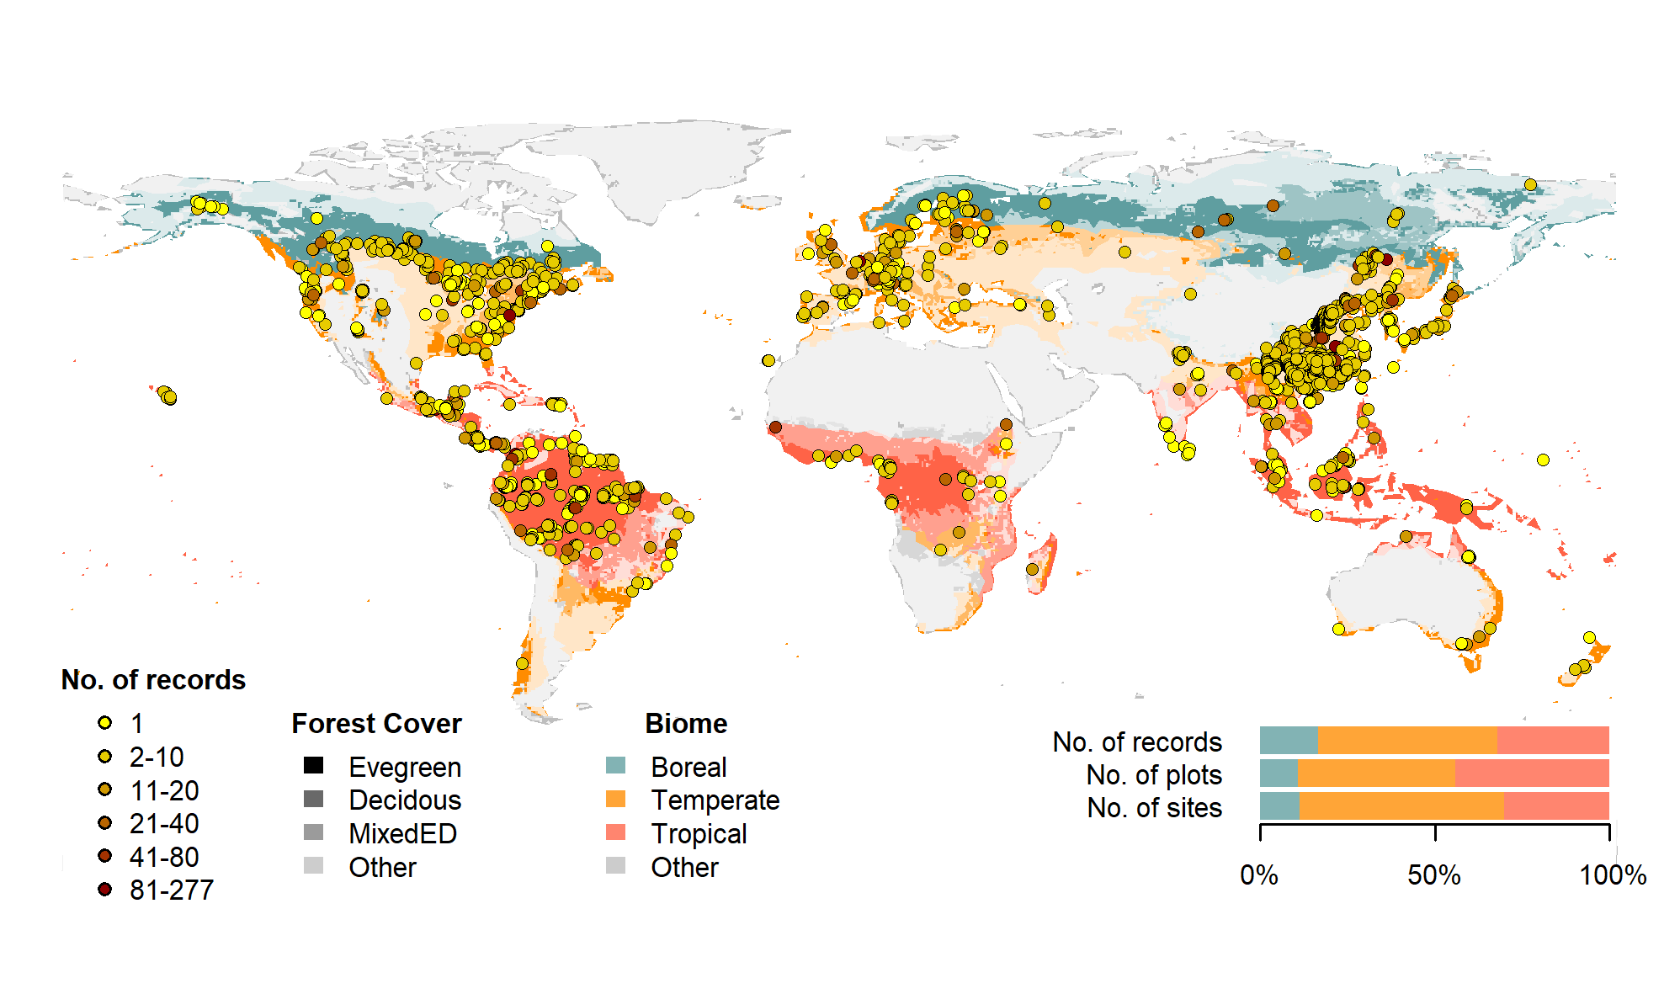

Figure 1 | Map of sites included in this analysis. Symbols are colored according to the number of records at each site. Underlying map shows coverage of evergreen, deciduous, and mixed forests (from SYNMAP; Jung et al. 2006) and biomes. Distribution of sites, plots, and records among biomes is shown in the inset.

## Methods/ Design

This review synthesizes data from the *ForC* database (Fig. 1; <https://github.com/forc-db/ForC>; Anderson-Teixeira *et al* 2016, pp @anderson–teixeira_forc_2018). *ForC* amalgamates numerous intermediary data sets (*e.g.*, Luyssaert *et al* 2007, Bond-Lamberty and Thomson 2010, Cook-Patton *et al* 2020) and original studies. Original publications were referenced to check values and obtain information not contained in intermediary data sets, although this process has not been completed for all records. The database was developed with goals of understanding how C cycling in forests varies across broad geographic scales and as a function of stand age. As such, there has been a focus on incorporating data from regrowth forests (*e.g.*, Anderson et al 2006, Martin et al 2013, Bonner et al 2013) and obtaining stand age data when possible (83% of records in v.2.0; Anderson-Teixeira *et al* 2018). Particular attention was given to developing the database for tropical forests (Anderson-Teixeira *et al* 2016), which represented roughly one-third of records in *ForC* v.2.0* (Anderson-Teixeira *et al* 2018). Since publication of ForC v.2.0, we added the following data to ForC: the Global Database of Soil Respiration Database (*SRDB* v.##, 9497 records; Bond-Lamberty and Thomson 2010), the Global Reforestation Opportunity Assessment database (*GROA* v1.0, 18143 records; Cook-Patton *et al* 2020, Anderson-Teixeira *et al* 2020). We’ve also added data from individual publications (detailed list at <https://github.com/forc-db/ForC/blob/master/database_management_records/ForC_data_additions_log.csv>), with a particular focus on productivity (Banbury Morgan *et al* n.d., e.g., Taylor *et al* 2017), dead wood, and ForestGEO sites (e.g., Lutz *et al* 2018, p @johnson_climate_2018). We note that there remains a significant amount of relevant data that is not yet included in ForC, particularly biomass data from national forest inventories (*e.g.*,: **REFS**). The database version used for this analysis has been tagged as a new release on Github (**XX**) and assigned a DOI through Zenodo (DOI: TBD).

To facilitate analyses, we created a simplified version of ForC, *ForC-simplified* (<https://github.com/forc-db/ForC/blob/master/ForC_simplified>), which we analyzed here. In generating *ForC-simplified*, all measurements originally expressed in units of dry organic matter ($OM$) were converted to units of C using the IPCC default of $C=0.47*OM$ (IPCC 2006). Duplicate or otherwise conflicting records were reconciled as described in *APPENDIX S1*, resulting in a total of 30927 records (64.6% size of total database). Records were filtered to remove plots that had undergone significant anthropogenic management or major disturbance since the most recent stand initiation event. Specifically, we removed all plots flagged as managed in ForC-simplified (19%). This included plots with any record of managements manipulating CO2, temperature, hydrology, nutrients, or biota, as well as any plots whose site or plot name contained the terms “plantation”, “planted”, “managed”, “irrigated”, or “fertilized”. Plots flagged as disturbed in ForC-simplified (5.9%) included stands that had undergone any notable anthropogenic thinning or partial harvest. We retained sites that were grazed or had undergone low severity natural disturbances (<10% mortality) including droughts, major storms, fires, and floods. We removed all plots for which no stand history information had been retrieved (7.7%). In total, this resulted in 21872 records (45.7% of the records in the database) being eligible for inclusion in the analysis.

We selected 23 annual flux and 11 C stock variables for inclusion in the analysis. These different flux and stock variables (Table 1) represent different pools (e.g., aboveground biomass, dead wood, ecosystem total) and levels of combination (e.g., total aboveground net primary productivity ($ANPP$) versus the ANPP of individual elements such as foliage, roots, and branches. Note that two flux variables, aboveground heterotropic ($R_{het−ag}$) and total ($R_{het}$) respiration, were included for conceptual completeness but had no records in *ForC* (Table 1). Records for these variables represented 89.1% of the total records eligible for inclusion. For this analysis, we combined some of ForC’s specific variables (*e.g.*, multiple variables for net primary productivity, such as measurements including or excluding fruit and flower production and herbivory) into more broadly defined variables. Specifically, net ecosystem exchange (measured by eddy-covariance; **FLUXNET REF**) and biometric estimates of $NEP$ were combined into the single variable $NEP$ (Table 1). Furthermore, for $NPP$, $ANPP$, and $ANPP_{litterfall}$, *ForC* variables specifying inclusion of different components were combined. Throughout ForC, for all measurements drawing from tree census data (*e.g.*, biomass, productivity), the minimum diameter breast height (DBH) threshold for tree census was $≤$ 10cm. All records were measured directly or derived from field measurements (as opposed to modeled).

For this analysis, we grouped forests into four broad biome types based on climate zones and dominant vegetation type (tropical broadleaf, temperate broadleaf, temperate needleleaf, and boreal needleleaf) and two age classifications (young and mature). Climate zones (Fig. 1) were defined based on site geographic coordinates according to Köppen-Geiger zones (Rubel and Kottek 2010). We defined the tropical biome as including all equatorial (A) zones, temperate biomes as including all warm temperate (C) zones and warmer snow climates (Dsa, Dsb, Dwa, Dwb, Dfa, and Dfb), and the boreal biome as including the colder snow climates (Dsc, Dsd, Dwc, Dwd, Dfc, and Dfd). Any forests in dry (B) and polar (E) Köppen-Geiger zones were excluded from the analysis. We defined leaf type (broadleaf / needleleaf) was based on descriptions in original publications (prioritized) or values extracted from a global map based on satellite observations (SYNMAP; **???**). For young tropical forests imported from *GROA* but not yet classified by leaf type, we assumed that all were broadleaf, consistent with the rarity of naturally regenerating needleleaf forests in the tropics (**REF**). We also classified forests as “young” (< 100 years) or “mature” ( $≥$ 100 years or classified as “mature”, “old growth”, “intact”, or “undisturbed” in original publication). Assigning stands to these groupings required the exclusion of records for which *ForC* lacked geographic coordinates (0.4% of sites in full database) or records of stand age (4.8% of records in full database). We also excluded records of stand age = 0 year (0.8% of records in full database). In total, our analysis retained 76.2 of the focal variable records for forests of known age. Numbers of records by biome and age class are given in Table S1.

Data were summarized to produce schematics of C cycling across the eight biome by age group combinations identified above. To obtain the values reported in the C cycle schematics, we first averaged any repeated measurements within a plot. Values were then averaged across geographically distinct areas, defined as plots clustered within 25 km of one another (*sensu* Anderson-Teixeira *et al* 2018), weighting by area sampled if available for all records. This step was taken to avoid pseudo-replication and to combine any records from sites with more than one name in ForC.

We tested whether the C budgets described above “closed”–*i.e.*, whether they were internally consistent. Specifically, we first defined relationships among variables: for example, , , ). **(**[**issue #44**](https://github.com/forc-db/ERL-review/issues/44)**–but just delete this chunk if not resolved before submission)** Henceforth, we refer to the variables on the left side of the equation as “aggregate” fluxes or stocks, and those that are summed as “component” fluxes or stocks, noting that the same variable can take both aggregate and component positions in different relationships. We considered the C budget for a given relationship “closed” when component variables summed to within one standard deviation of the aggregate variable.

To test for differences across mature forest biomes, we also examined how stand age impacted fluxes and stocks, employing a mixed effects model [‘lmer’ function in ‘lme4’ R package version **x.xx**; **REF**] with biome as fixed effect and plot nested within geographic.area as random effects on the intercept. When Biome had a significant effect, we looked at a Tukey’s pairwise comparison to see which biomes were significantly different from one another. This analysis was run for variables with records for at least seven distinct geographic areas in more than one biome, excluding any biomes that failed this criteria (Table 1).

To test for age trends in young (<100yrs) forests, we employed a mixed effects model with biome and log10[stand.age] as fixed effects and plot nested within geographic.area as a random effect on the intercept. This analysis was run for variables with records for at least three distinct geographic areas in more than one biome, excluding any biomes that failed this criteria (Table 1). When the effect of stand age was significant at p $≤$ 0.05 and when each biome had records for stands of at least 10 different ages, a biome $×$ stand.age interaction was included in the model.

To facilitate the accessibility of our results and data, and to allow for rapid updates as additional data become available, we have automated all database manipulation, analyses, and figure production in R (**version, citation**).

## Review Results/ Synthesis

### Data Coverage

Of the 47846 records in *ForC* v3.0, 14847 met our strict criteria for inclusion in this study (Fig. 1). These records were distributed across 5889 plots in 874 distinct geographic areas. Of the 23 flux and 11 stock variables mapped in these diagrams, *ForC* contained sufficient mature forest data for inclusion in our statistical analyses (*i.e.*, records from $≥$ 7 distinct geographic areas) for 20 fluxes and 9 stocks in tropical broadleaf forests, 14 fluxes and 9 stocks in temperate broadleaf forests, 15 fluxes and 8 stocks in temperate conifer forests, and 8 fluxes and 7 stocks in boreal forests. For regrowth forests (<100 yrs), *ForC* contained sufficient data for inclusion in our statistical analyses (*i.e.*, records from $≥$**3** distinct geographic areas) for 10 fluxes and 10 stocks in tropical broadleaf forests, 16 fluxes and 10 stocks in temperate broadleaf forests, 17 fluxes and 10 stocks in temperate conifer forests, and 14 fluxes and 9 stocks in boreal forests.

### C cycling in mature forests

Average C cycles for mature tropical broadleaf, temperate broadleaf, temperate conifer, and boreal forests $≥$ 100 years old and with no known major natural or anthropogenic disturbance are presented in Figures 2-5 (and available in tabular format in the *ForC* release accompanying this publication: ForC/numbers_and_facts/ForC_variable_averages_per_Biome.csv).

For variables with records from $≥$ 7 distinct geographic areas, these ensemble C budgets were generally consistent. *That is, component variables summed to within one standard deviation of their respective aggregate variables in all but* **two** *instances, both in temperate conifer forests (Fig. 5).* **(check all this with final results:** [**https://github.com/forc-db/ForC/blob/master/numbers_and_facts/C_cycle_closure.csv**](https://github.com/forc-db/ForC/blob/master/numbers_and_facts/C_cycle_closure.csv)**, and be sure to write out variable names at first occurance, and provide a bit more detail)**  *For the temperate conifer biome, the average composite measure of aboveground biomass (Bag) was less than the combined average value of woody biomass (Bag-wood) and foliage biomass (Bfoliage), partly due to the very high estimates of Bag-wood.* *Within this biome, $B_{ag}<B_{ag−wood}+B_{foliage}$ and $B_{root}<B_{root−coarse}+B_{root−fine}$ because $B_{ag−wood}$ and $B_{root−coarse}$ were very high, with strongly disproportionate numbers of records from the high-biomass forests of the US Pacific Northwest (Figs. S18, S21).*

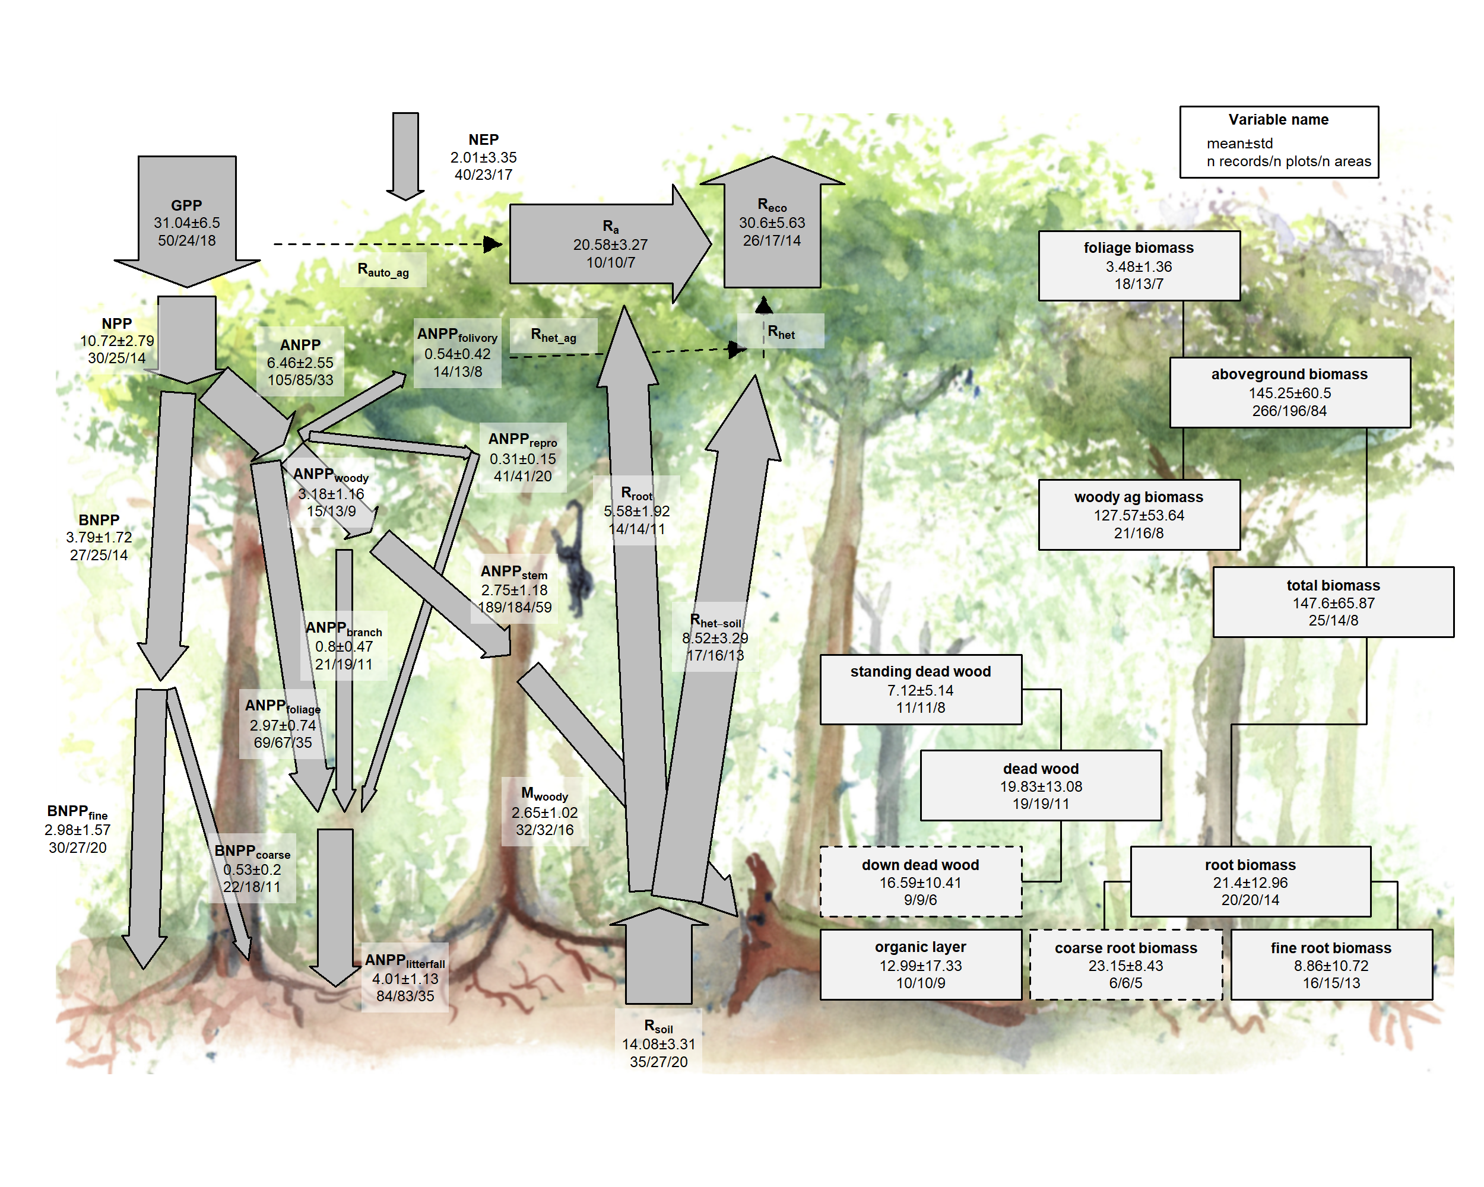

Figure 2 | C cycle diagram for mature tropical broadleaf forests. Arrows indicate fluxes (Mg C ha $​^{−1}$ yr $​^{−1}$); boxes indicate stocks (Mg C ha $​^{−1}$), with variables as defined in Table 1. Presented are mean ± std, where geographically distinct areas are treated as the unit of replication. Dashed shape outlines indicate variables with records from <7 distinct geographic areas, and dashed arrows indicate fluxes with no data. To illustrate the magnitude of different fluxes, arrow size is proportional to the square root of corresponding flux. Asterisk after variable name indicates lack of C cycle closure.

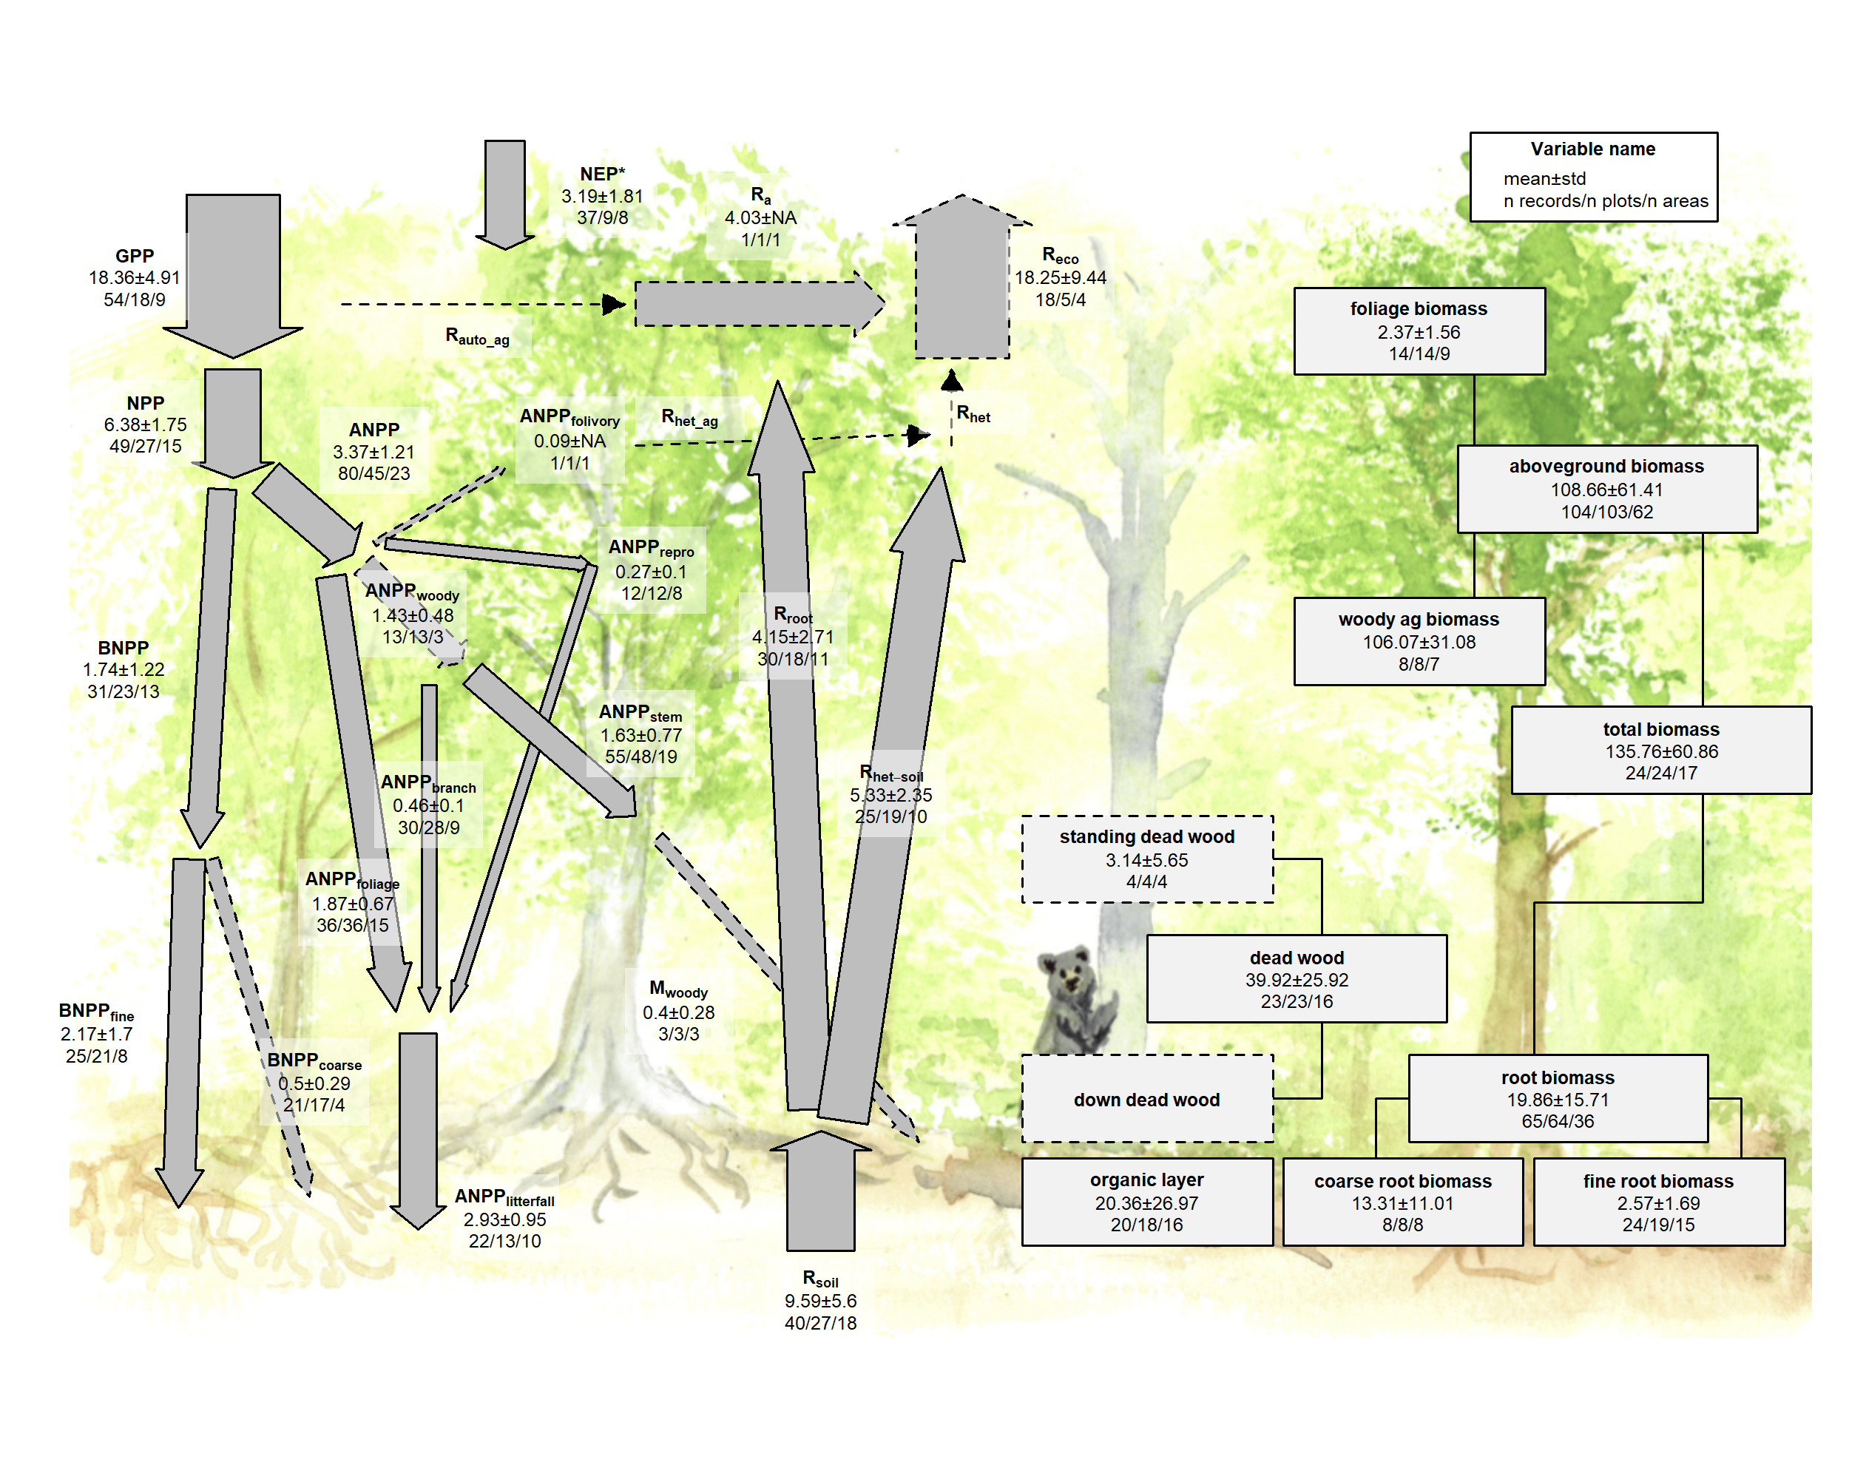

Figure 3 | C cycle diagram for mature temperate broadleaf forests. Arrows indicate fluxes (Mg C ha $​^{−1}$ yr $​^{−1}$); boxes indicate stocks (Mg C ha $​^{−1}$), with variables as defined in Table 1. Presented are mean ± std, where geographically distinct areas are treated as the unit of replication. Dashed shape outlines indicate variables with records from <7 distinct geographic areas, and dashed arrows indicate fluxes with no data. To illustrate the magnitude of different fluxes, arrow size is proportional to the square root of corresponding flux. Asterisk after variable name indicates lack of C cycle closure.

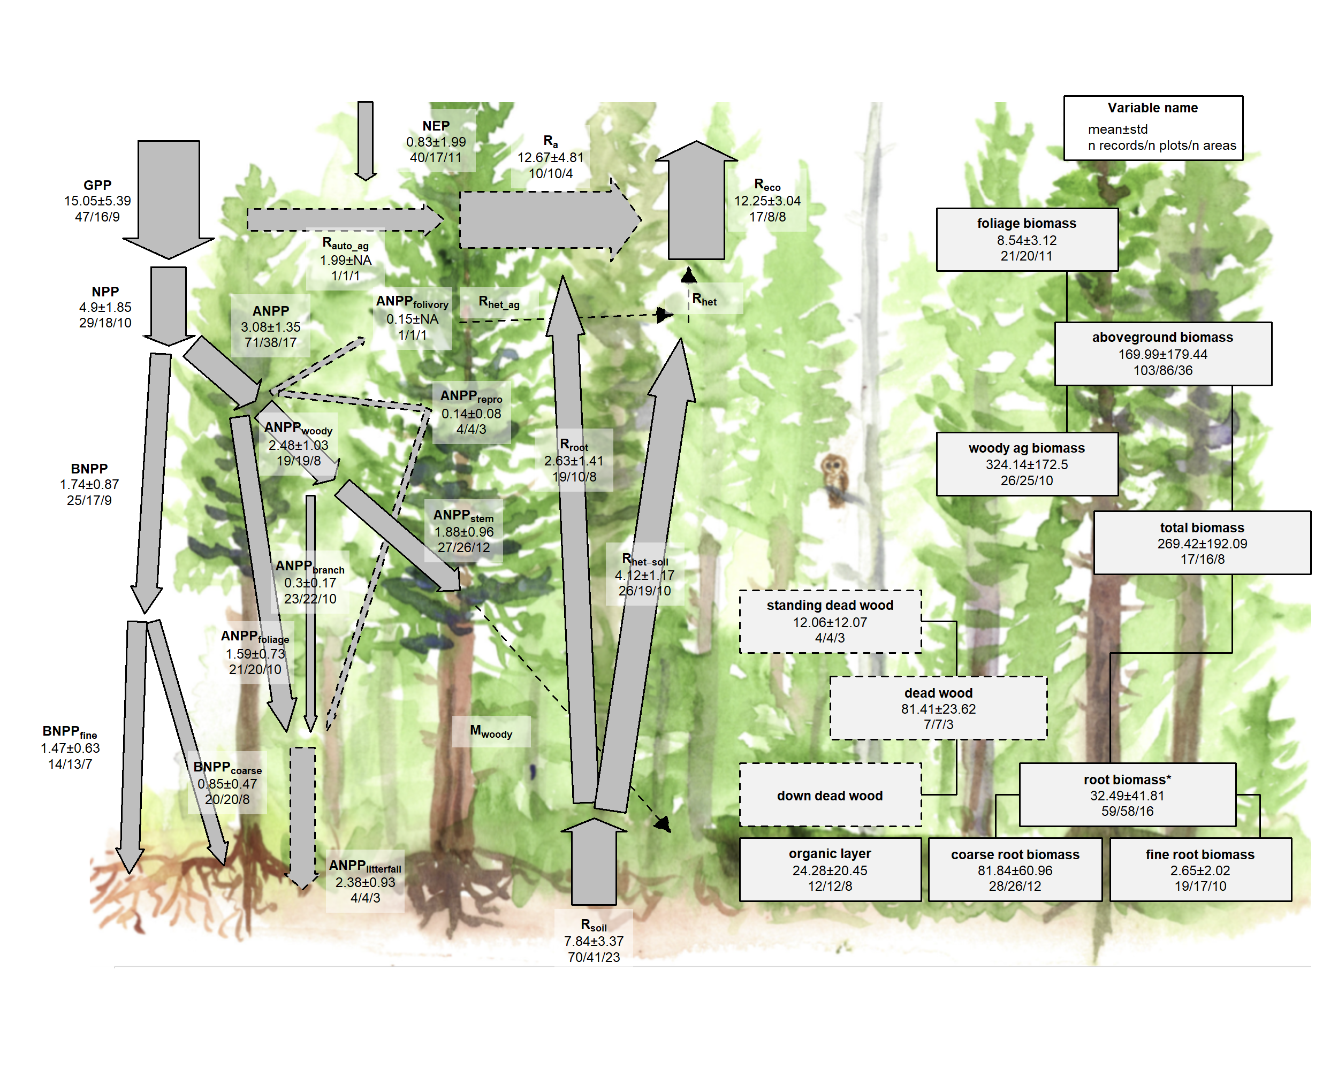

Figure 4 | C cycle diagram for mature temperate conifer forests. Arrows indicate fluxes (Mg C ha $​^{−1}$ yr $​^{−1}$); boxes indicate stocks (Mg C ha $​^{−1}$), with variables as defined in Table 1. Presented are mean ± std, where geographically distinct areas are treated as the unit of replication. Dashed shape outlines indicate variables with records from <7 distinct geographic areas, and dashed arrows indicate fluxes with no data. To illustrate the magnitude of different fluxes, arrow size is proportional to the square root of corresponding flux. Asterisk after variable name indicates lack of C cycle closure.

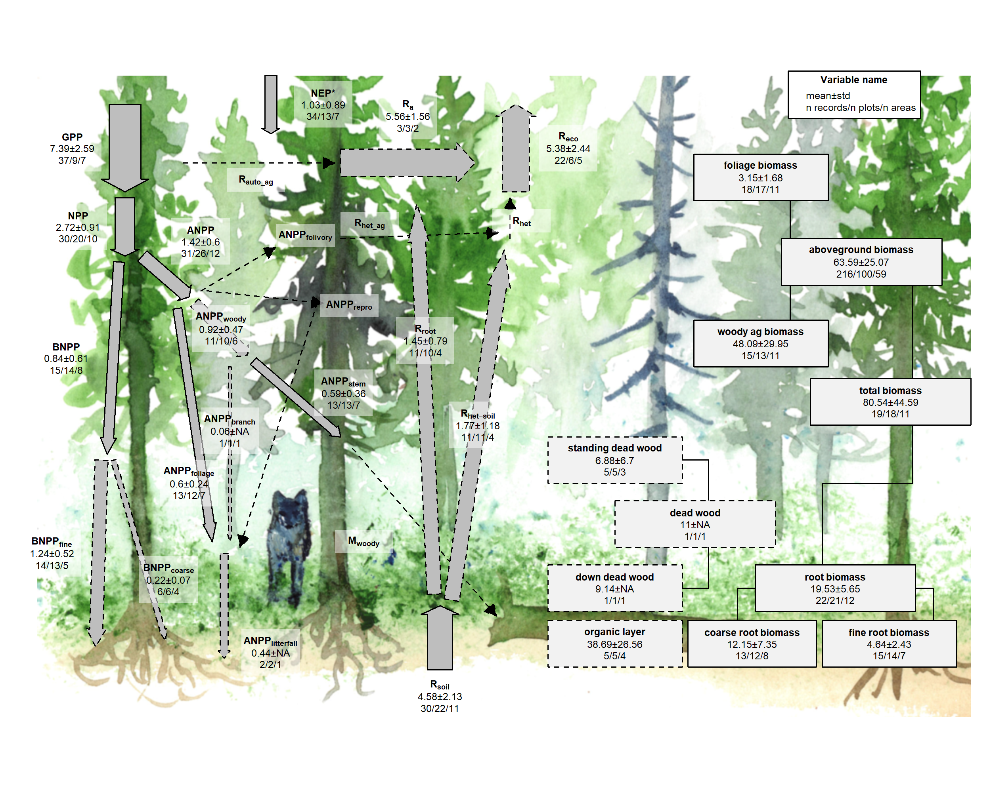

**check this with final data (based on Table 1):** There were sufficient data to assess mature forest biome differences for **20** flux variables, and significant differences among biomes were detected for **14** variables (Table 1). In all cases–including C fluxes into, within, and out of the ecosystem–C fluxes were highest in tropical forests, intermediate in temperate (broadleaf or conifer) forests, and lowest in boreal forests (Table 1, Figs. 6, S1-S15). Differences between tropical and boreal forests were always significant, with temperate forests intermediate and significantly different from one or both. Fluxes tended to be numerically greater in temperate broadleaf than conifer forests, but the difference was never statistically significant. This pattern held for the following variables: $GPP$** , $NPP$, $ANPP$, $ANPP_{woody}$, $ANPP_{stem}$, $ANPP_{branch}$, $ANPP_{foliage}$, $ANPP_{litterfall}$, $M_{woody}$, $BNPP$, $R_{eco}$, $R_{soil}$, and $R_{het−soil}$**. For variables without significant differences among biomes, the same general trends applied.

The most notable exception to this pattern was $NEP$, with no significant differences across biomes but with the largest average in temperate broadleaf forests, followed by temperate conifer, boreal, and tropical forests (Figs. 5,S1). Another exception was for $BNPP_{root−coarse}$, where all records came from high-biomass forests in the US Pacific Northwest, resulting in high values for the temperate conifer biome and no significant differences across biomes (Fig. S10).  
Thus, C cycling rates generally decreased from tropical to temperate to boreal forests, with the important exception in the overall C balance ($NEP$).

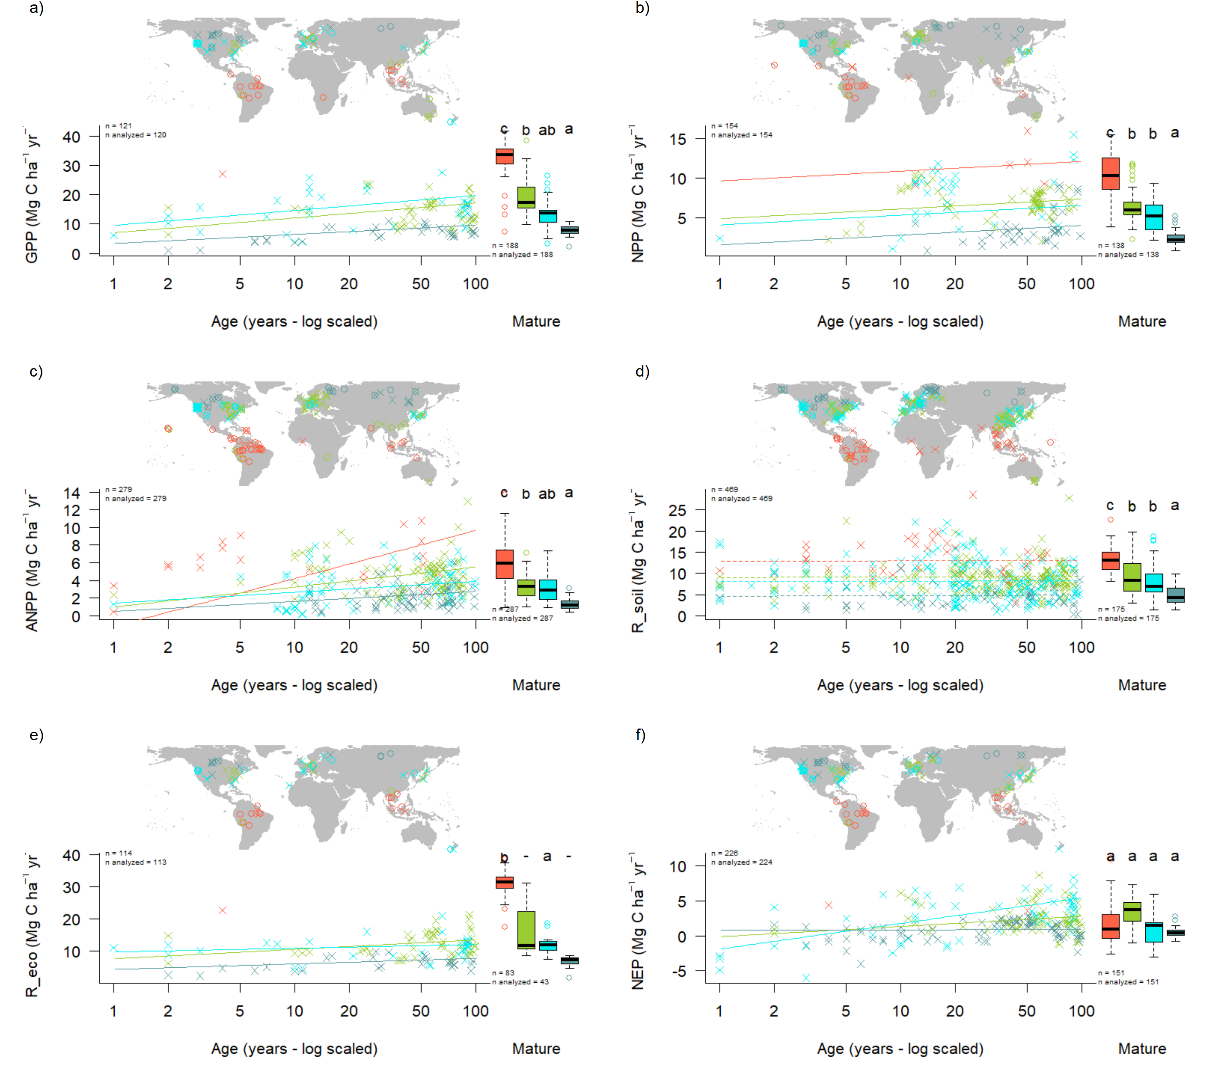

Figure 6 | Age trends and biome differences in some of the major C fluxes: (a) $GPP$, (b) $NPP$, (c) $ANPP$, (d) $R_{soil}$, (e) $R_{eco}$, and (f) $NEP$. Map shows data sources ( $x$ and $o$ indicate young and mature stands, respectively). In each panel, the left scatterplot shows age trends in forests up to 100 years old, as characterized by a linear mixed effects model with fixed effects of age and biome. The fitted line indicates the effect of age on flux (solid lines: significant at p<0.05, dashed lines: non-significant), and non-parallel lines indicate a significant age x biome interaction. The boxplot illustrates distribution across mature forests, with different letters indicating significant differences between biomes. Data from biomes that did not meet the sample size criteria (see Methods) are plotted, but lack regression lines (young forests) or test of differences across biomes (mature forests). Individual figures for each flux with sufficient data are given in the Supplement (Figs. S1-S15).

**check this with final data (based on Table 1):** There were sufficient data to assess mature forest biome differences for **9** stock variables, and significant differences among biomes were detected for **6** variables ($B_{tot}$**, $B_{ag}$, $B_{ag−wood}$, $B_{foliage}$, $B_{root−coarse}$, $DW_{tot}$** ; Table 1). C stocks had less consistent patterns across biomes (Figs. 7, S16-S26). In **four of the six** cases ($B_{tot}$**, $B_{ag−wood}$, $B_{root−coarse}$, $DW_{tot}$** ), temperate conifer forests had significantly higher stocks than the other biomes, and boreal forests in the lowest, with tropical and temperate broadleaf forests in between. For $B_{ag}$, which had by far the highest sample size, tropical forests exceeded temperate conifer forests (but not significantly). For $B_{foliage}$,temperate broadleaf forests were lowest (again, not significantly). The high values for the temperate conifer biome were driven by the very high-biomass forests of the US Pacific Northwest, which are disproportionately represented in the current version of ForC. Thus, biome differences should be interpreted more as driven more by geographic distribution of sampling than by true differences.

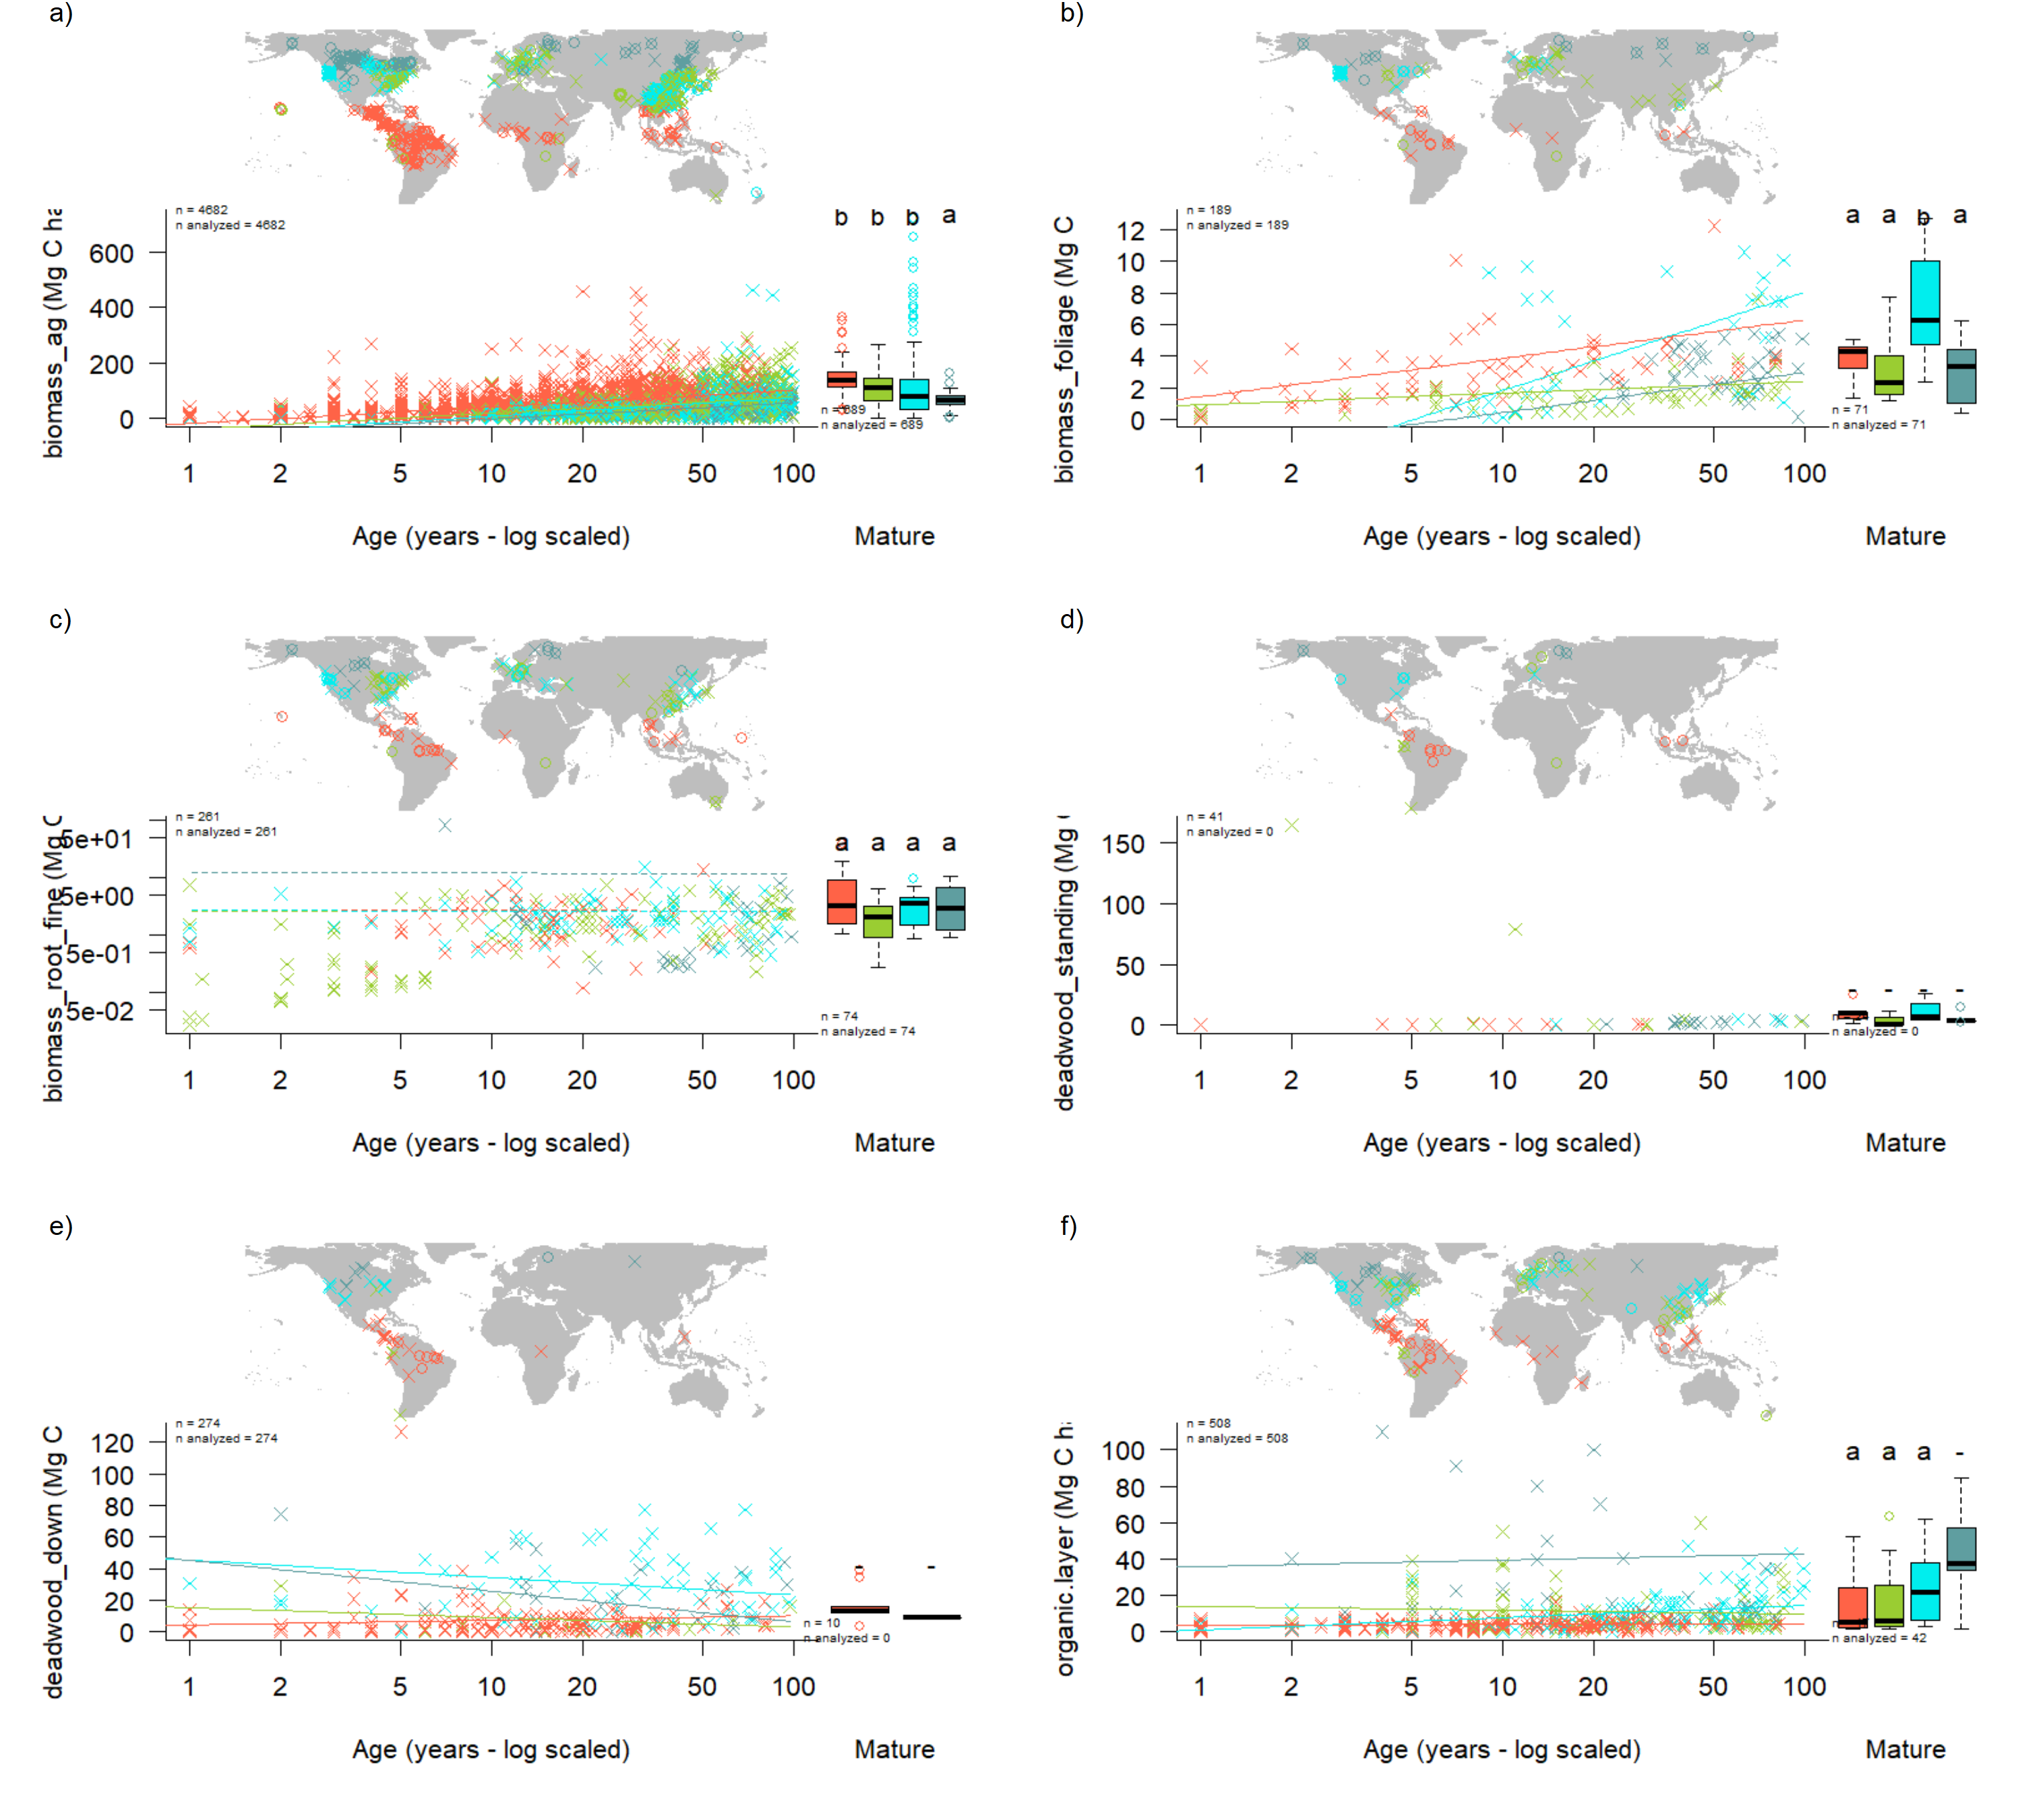

Figure 7 | Age trends and biome differences in some of the major forest C stocks: (a) aboveground biomass, (b) foliage, (c) fine roots, (d) dead wood. Map shows data sources ( $x$ and $o$ indicate young and mature stands, respectively). In each panel, the left scatterplot shows age trends in forests up to 100 years old, as characterized by a linear mixed effects model with fixed effects of age and biome. The fitted line indicates the effect of age on flux (solid lines: significant at p<0.05, dashed lines: non-significant), and non-parallel lines indicate a significant age x biome interaction. The boxplot illustrates distribution across mature forests, with different letters indicating signifant differences between biomes. Data from biomes that did not meet the sample size criteria (see Methods) are plotted, but lack regression lines (young forests) or test of differences across biomes (mature forests). Individual figures for each stock with sufficient data are given in the Supplement (Figs. S16-S26).

### C cycling in young forests

Average C cycles for forests <100 years old are presented in Figures 8-11.  
Both C stocks and fluxes commonly increased signficantly with stand age (Tables 1, S2, Figs. 6-11, S1-S26; detailed below).

*ForC* contained *14* flux variables with sufficient data for cross-biome analyses of age trends in regrowth forests (see Methods) (Fig. 6-7 and **S#- SI figures including plots for all variables**). Of these, *9* increased significantly with age: $GPP$, $NPP$, $ANPP$, $ANPP_{foliage}$, $ANPP_{woody}$, $ANPP_{woody−stem}$, $BNPP$, $BNPP_{root−fine}$, $R_{eco}$, and net C sequestration ($NEP$). The remaining five– $ANPP_{woody−branch}$, $BNPP_{root−coarse}$, $R_{soil−het}$, and $R_{soil−het}$-–displayed no significant relationship to stand age, although all displayed a positive trend.

Differences in C fluxes across biomes typically paralleled those observed for mature forests, with C cycling generally most rapid in the tropics and slowest in boreal forests.  
The single exception was $ANPP_{stem}$, for which temperate broadleaf forests and temperate conifer forests of age >*~30* had slightly higher flux rates than tropical forests (*represented by a single chronosequence*). Notably, the trend of tropical > temperate > boreal held for $NEP$ in regrowth forests, in contrast to the lack of biome differences in $NEP$ for mature forests (Fig. 6).

There were only *##* flux variables with sufficient data to test for biome x age interactions: $ANPP$, $ANPP_{woody}$, $ANPP_{stem}$, $ANPP_{litterfall}$, and $BNPP$ (Table S2). **(more could be added if age trends become significant after outliers are resolved)** For three of these ($ANPP$, $ANPP_{litterfall}$, $BNPP$), the increase in C flux with age was steepest increase in tropical forests, followed by temperate and then boreal forests (Figs S#). Similarly, $ANPP_{woody}$ displayed a steeper increase with age in temperate than boreal boreal forests (no tropical data for this variable). In contrast, for $ANPP_{stem}$, tropical and temperate broadleaf forests had the highest flux rates at young ages, but were surpassed by temperate conifer forests between ages 20 and 50 (Fig. S6).

(**this needs to be updated with latest data**) In terms of C stocks, *10* variables had sufficient data to test for age trends. *Six* of these—*total biomass, aboveground biomass, aboveground woody biomass, foliage biomass, root biomass, and coarse root biomass*— increased significantly with $log10[stand.age]$. *The remaining four displayed non-significant positive trends: fine root biomass, total dead wood, standing dead wood, and organic layer.* *(discuss rates of increase)*

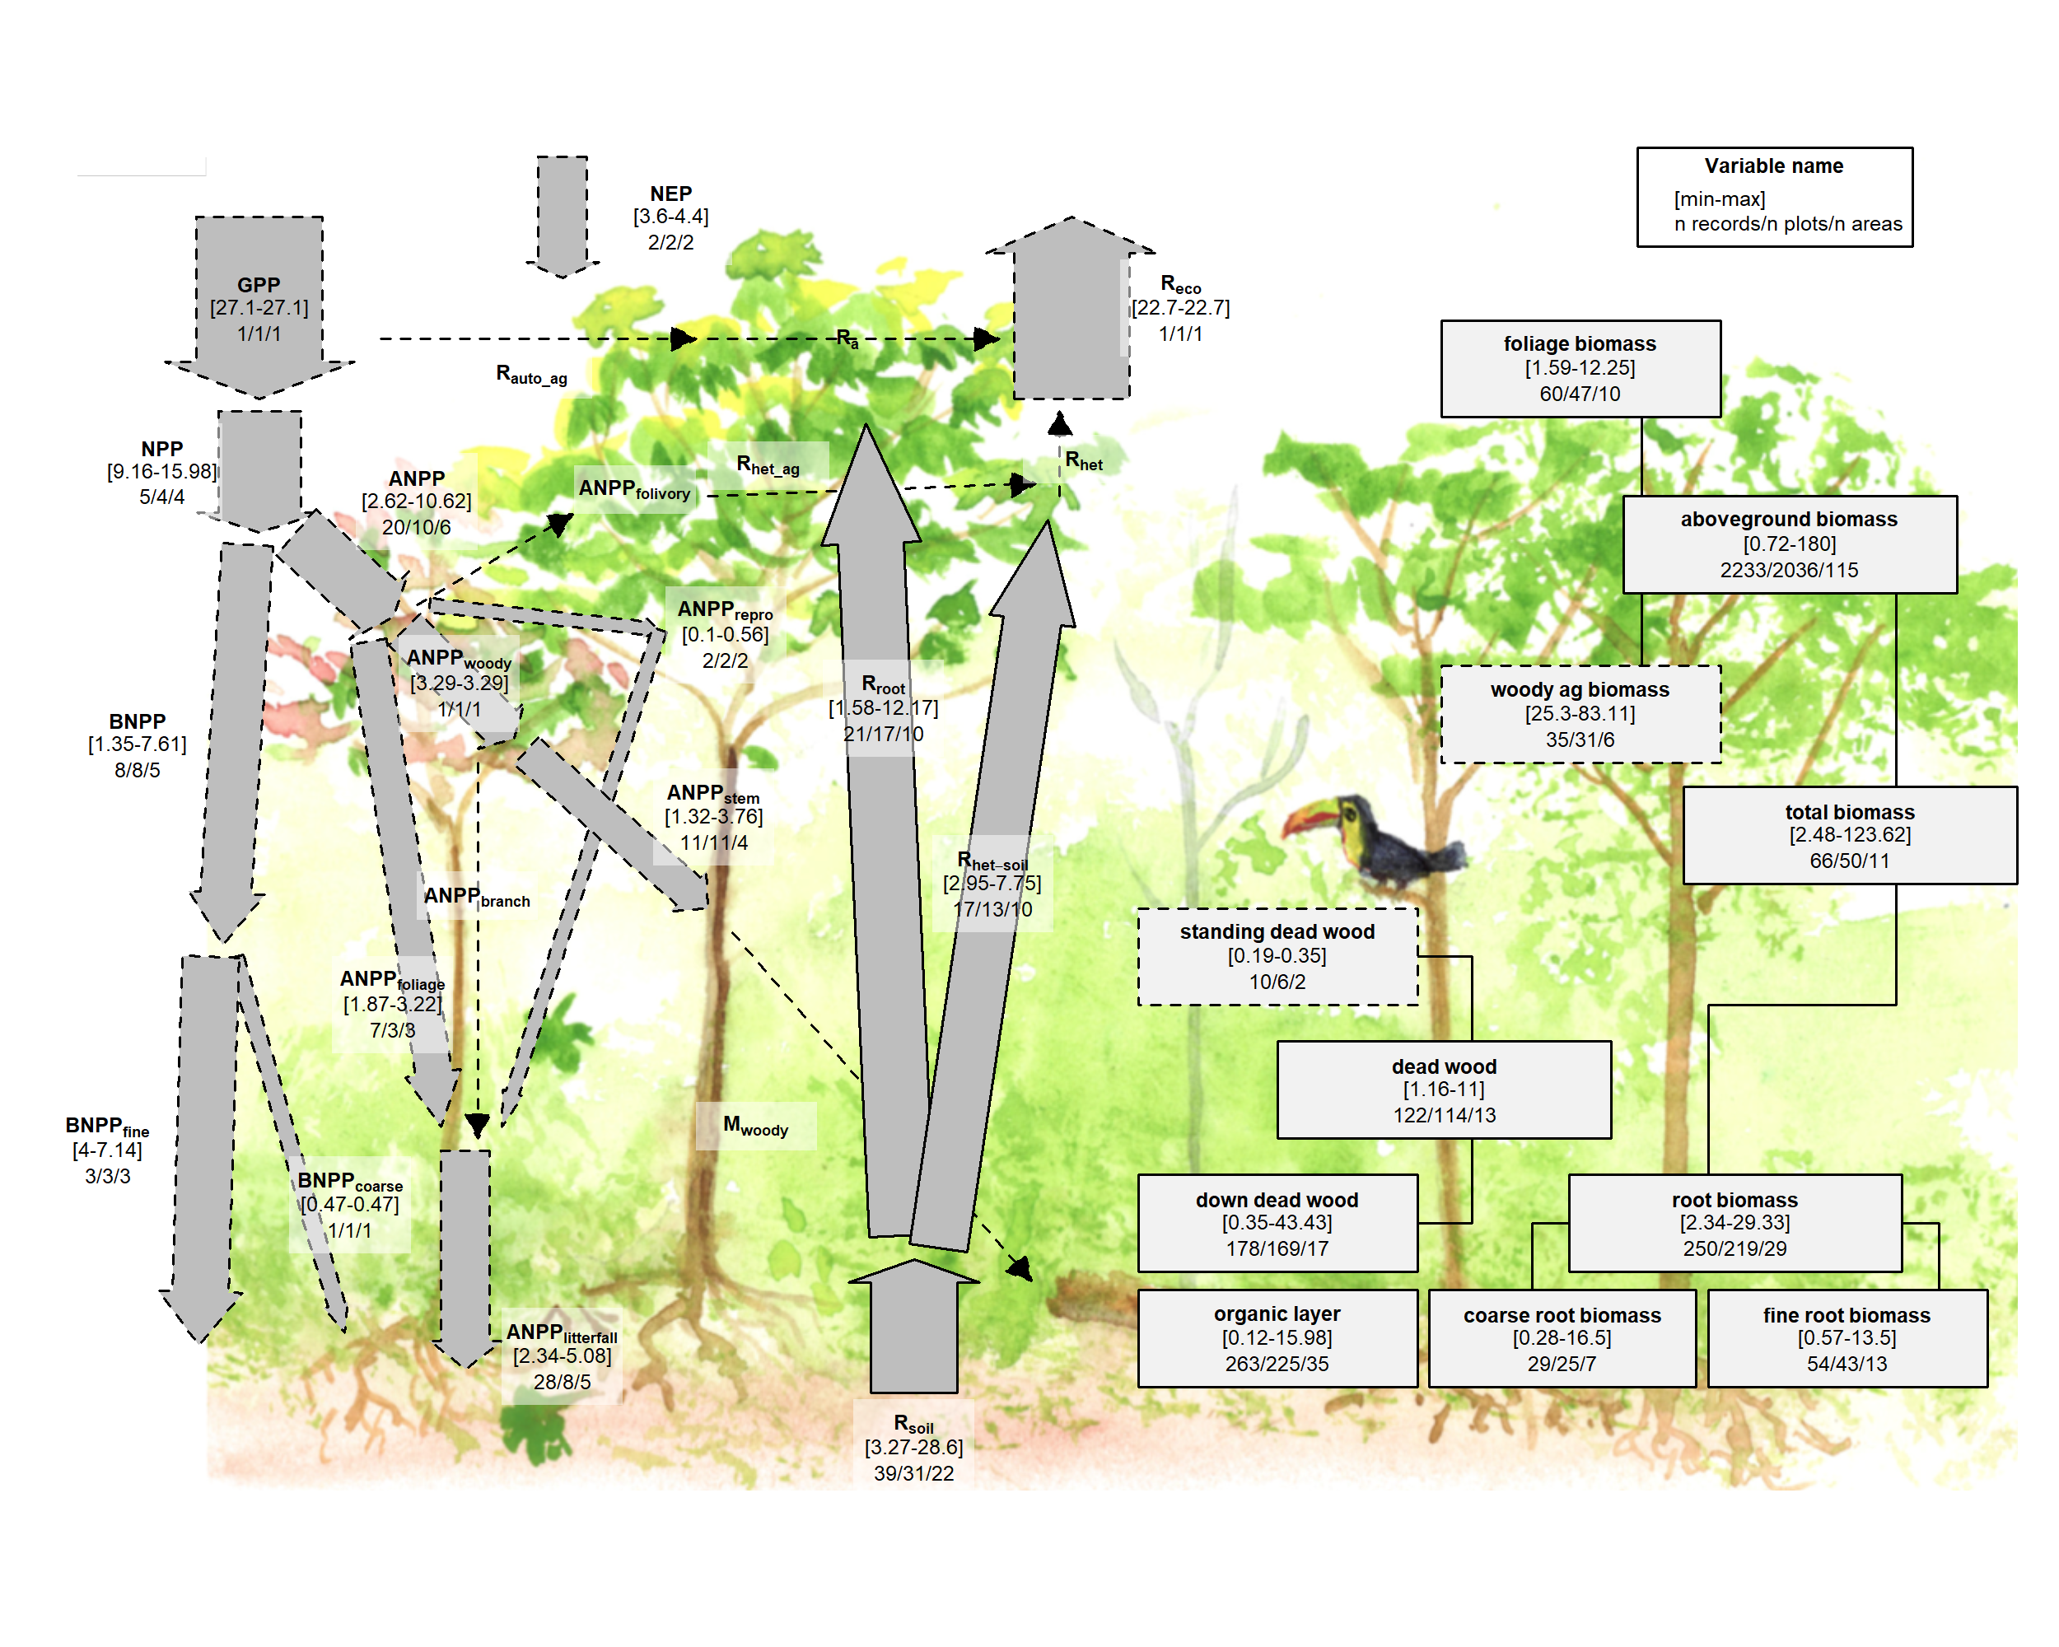

Figure 8 | C cycle diagram for young tropical broadleaf forests. Arrows indicate fluxes (Mg C ha $​^{−1}$ yr $​^{−1}$); boxes indicate stocks (Mg C ha $​^{−1}$), with variables as defined in Table 1. Presented are observed ranges, where geographically distinct areas are treated as the unit of replication. All units are Mg C ha yr (fluxes) or Mg C ha (stocks). Dashed shape outlines indicate variables with records from <7 distinct geographic areas, and dashed arrows indicate fluxes with no data. To illustrate the magnitude of different fluxes, arrow size is proportional to the square root of corresponding flux.

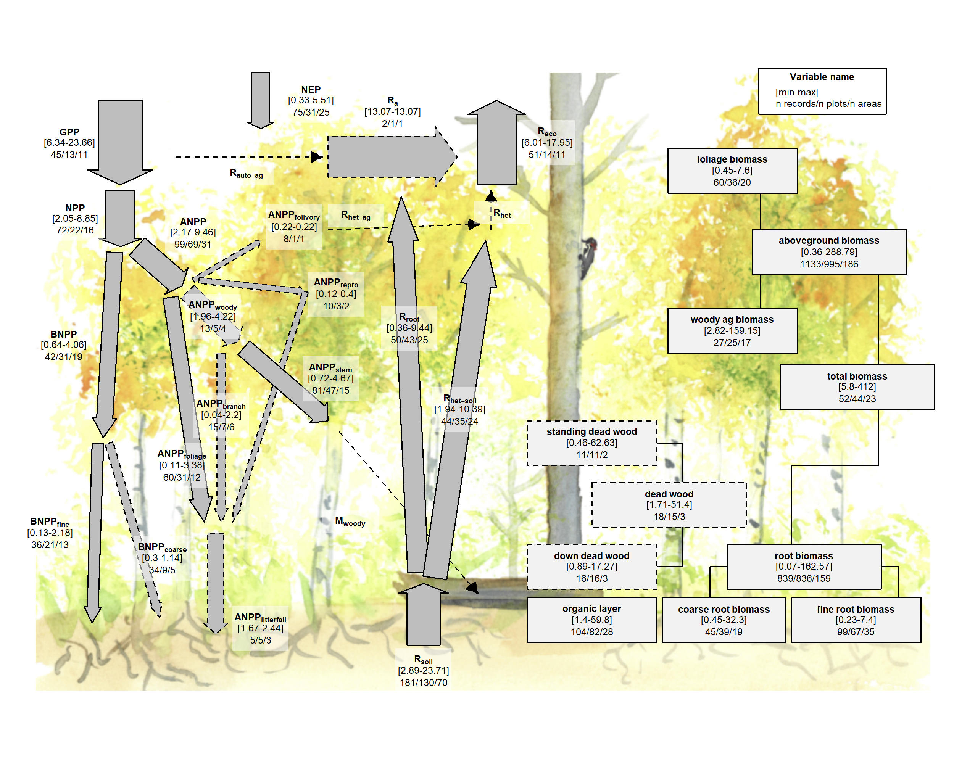

Figure 9 | C cycle diagram for young temperate broadleaf forests. Arrows indicate fluxes (Mg C ha $​^{−1}$ yr $​^{−1}$); boxes indicate stocks (Mg C ha $​^{−1}$), with variables as defined in Table 1. Presented are observed ranges, where geographically distinct areas are treated as the unit of replication. All units are Mg C ha yr (fluxes) or Mg C ha (stocks). Dashed shape outlines indicate variables with records from <7 distinct geographic areas, and dashed arrows indicate fluxes with no data. To illustrate the magnitude of different fluxes, arrow size is proportional to the square root of corresponding flux.

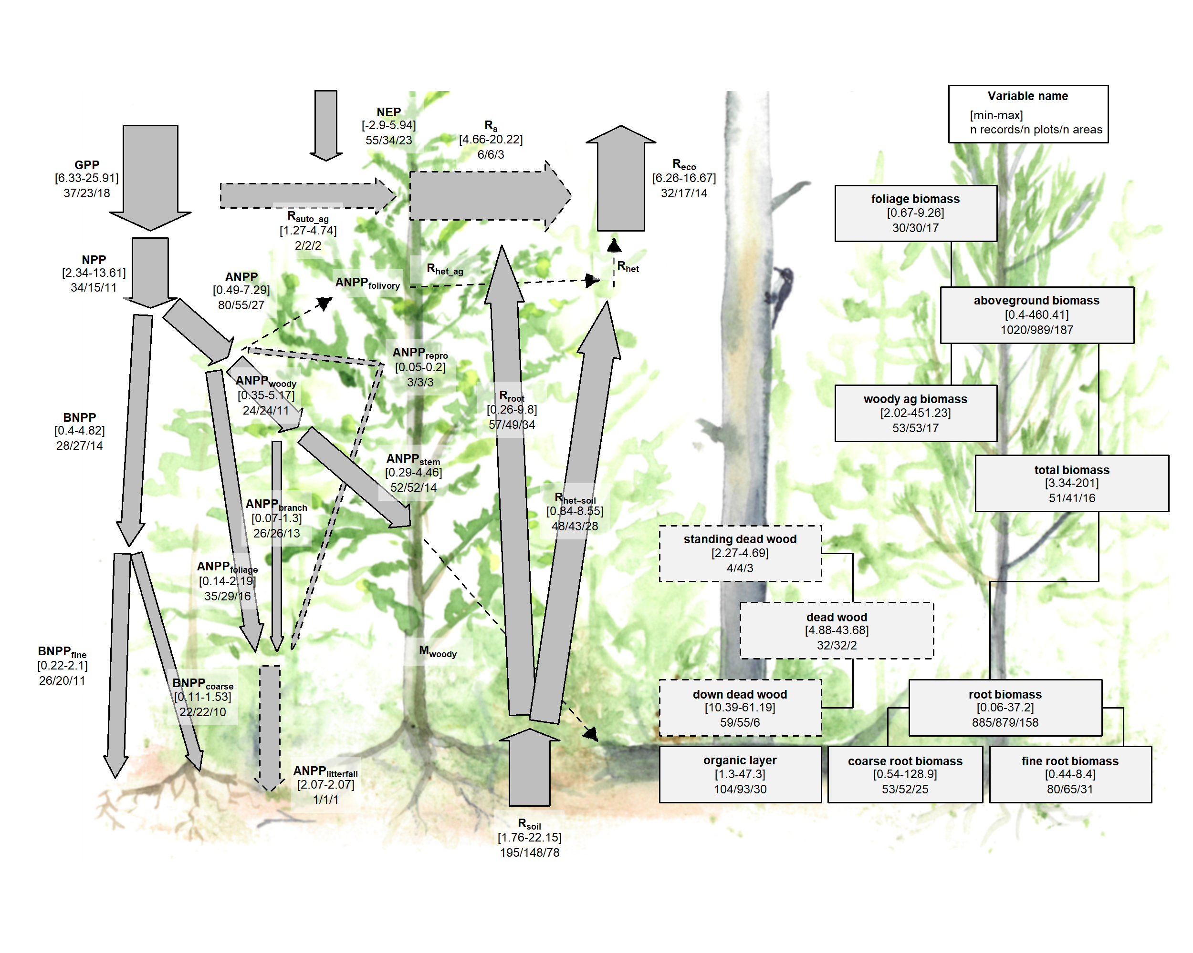

Figure 10 | C cycle diagram for young temperate conifer forests. Arrows indicate fluxes (Mg C ha $​^{−1}$ yr $​^{−1}$); boxes indicate stocks (Mg C ha $​^{−1}$), with variables as defined in Table 1. Presented are observed ranges, where geographically distinct areas are treated as the unit of replication. All units are Mg C ha yr (fluxes) or Mg C ha (stocks). Dashed shape outlines indicate variables with records from <7 distinct geographic areas, and dashed arrows indicate fluxes with no data. To illustrate the magnitude of different fluxes, arrow size is proportional to the square root of corresponding flux.

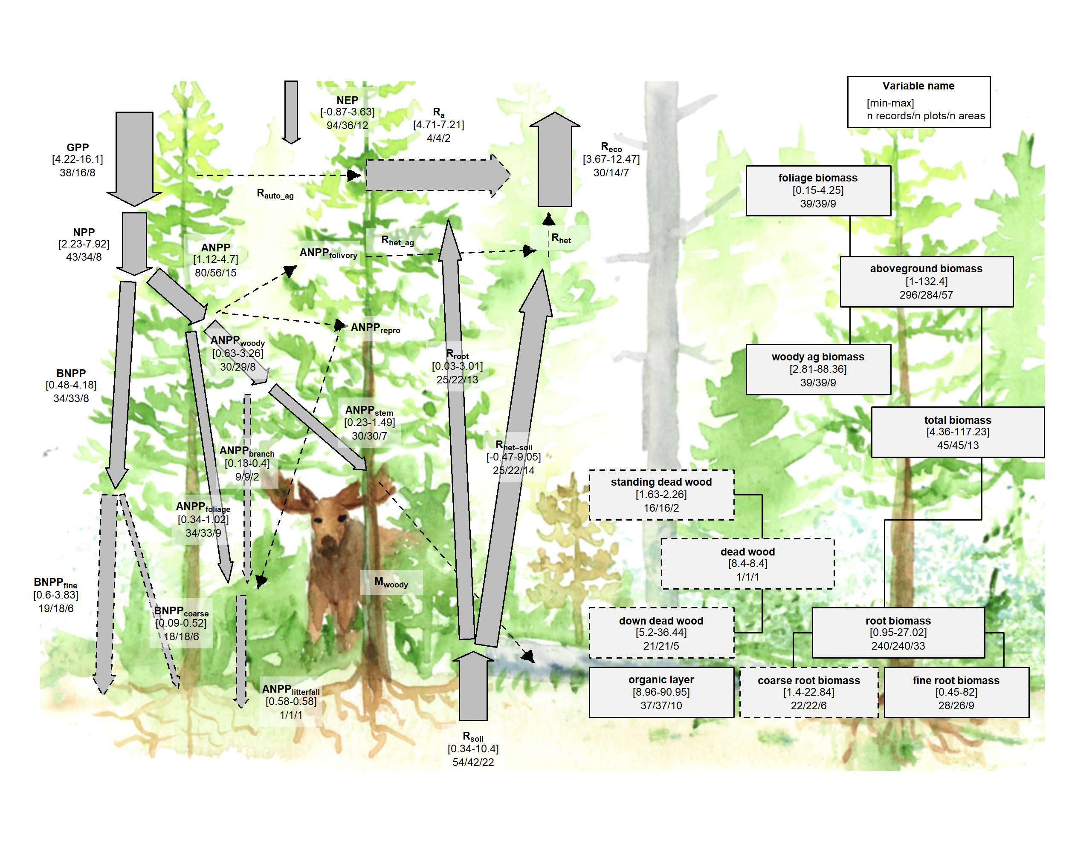

## Discussion

*ForC* v3.0 brought together an unprecedented amount of data to yield an internally consistent picture of C cycling in the world’s major forest biomes. Carbon cycling rates generally increased from boreal to tropical regions and with stand age. Specifically, the major C fluxes were highest in tropical forests, intermediate in temperate (broadleaf or conifer) forests, and lowest in boreal forests – a pattern that generally held for regrowth as well as mature forests (Figs. 6-7). In contrast to C fluxes, there was little directional variation in mature forest C stocks across biomes (Figs. 2-5, 7). The majority of flux variables, together with most live biomass pools, increased significantly with stand age (Figs. 6-11). Together, these results indicate that, moving from cold to tropical climates and from young to old stands, there is a general acceleration of C cycling, whereas C stocks and $NEP$ of mature forests are correlated with a different set of factors.

### C variable coverage and budget closure

*ForC* provides provides unprecedented coverage of most major variables. *(discuss how this improves upon previous data compilations/ for which variables does ForC make the greatest difference (e.g., not AGB or NEP/GPP/Reco, but by far the latest data compilation for dead wood, [variables])* *(Noteable holes include: fluxes: R_auto_ag, woody mortality, folivary/ herbivory and respiration of herbivores (and therefore total R_het), ANPP_repro; also fluxes in tropical regrowth forests)* *For the C stocks considered here, the most poorly covered is dead wood (none in E hemisphere!), despite a focused effort on this variable that has resulted in ForC being by far the largest collection of these data.* Thus, overall, we’re lacking coverage of fluxes to herbivores and higher consumers, along with the woody mortality and dead wood. Geographically, all variables poorly covered in Africa and Siberia.

**notes from Ben on the above par:** Pregitzer and Euskirchen 2004 <http://dx.doi.org/10.1111/j.1365-2486.2004.00866.x> “Aggregated biome-level estimates of NPP and NEP were higher in intermediate-aged forests (e.g., 30–120 years), while older forests (e.g., 4120 years) were generally less productive. The mean NEP in the youngest forests (0–10 years) was negative (source to the atmosphere) in both boreal and temperate biomes…Forest age is a highly significant source of variability in NEP at the biome scale”

Amiro et al. 2010 <http://dx.doi.org/10.1029/2010JG001390> Houghton et al. 2020 <https://doi.org/10.1111/gcb.15050>

Turnover: Pugh et al. 2020 <http://dx.doi.org/10.5194/bg-2019-491> Yu et al. 2019 <http://dx.doi.org/10.1073/pnas.1821387116>

Human footprint in global forests <http://dx.doi.org/10.1038/nature05847> <http://dx.doi.org/10.1038/nature02619>

Mention consistency (or lack of) with e.g. GOLUM-CNP? <http://dx.doi.org/10.5194/gmd-11-3903-2018>

In terms of C stocks, there is a paucity of data on dead wood and organic layer (Pan et al. ?). These can be significant. (**Note that we’ve given a lot of emphasis to dead wood (work by Abby, and also Jenny), and as a result this work really advances knowledge of dead wood. We’ll want to highlight that here.**) *(give some stats/ cite figures)*. *ForC* does not include soil carbon, which is covered by other efforts (REFS). For fluxes, Fluxnet is the keeper of the best data on NEE, GPP, Reco (REFS), and *SRDB* remains the authority on soil respiration (REFS). *ForC* includes recent data from both, but is not continuously integrated. For C is the best source for most of the subsidiary fluxes: NPP, woody mortality…

The C cycle budgets for mature forests (Figs. 2-5) generally “close”–that is, the sums of component variables do not differ from the larger fluxes by more than one standard deviation. However, standard deviations are often large, reflective of significant within-biome variation. This makes the standard for closure relatively loose. *Lack of closure, in the few instances where it occurs, is probably more reflective of differences in the representation of forest types (e.g., disproportionate representation of US Pacific NW for aboveground woody biomass relative to AGB; Fig. 4) than of methodological accuracy.* Thus, overall, a high degree of closure implies that *ForC* gives a consistent picture of C cycling within biomes. While these means are unlikely to be accurate representations of C cycling within any particular forest, they provide a useful baseline for comparison, always keeping in mind that sample means do not necessarily represent the true mean of the entire biome.

### C cycling across biomes

Our analysis reveals a general acceleration of carbon cycling from the tropics to the high latitudes. For mature forests, this is consistent with a large body of previous work demonstrating that C fluxes generally decline with latitude (e.g., Banbury Morgan *et al* n.d.). For regrowth forests, more rapid accumulation of biomass at lower latitudes has been well-established (Anderson *et al* 2006, Cook-Patton *et al* 2020), whereas this is the first study to compare age trends in deadwood and organic layer across biomes (but see Cook-Patton *et al* 2020). For most C flux variables, this analysis is the first to examine flux trends in regrowth forests across biomes (i.e., age x biome interaction). Data remain sparse, but for better-represented variables, we often see faster acceleration of C cycling in the warmer climates. Further work will be required to explore age x climate interactions, but our broad-brush overview indicates that C cycling of regrowth forests is not only higher in the tropics, parallel to fluxes in mature forests (Banbury Morgan *et al* n.d.), but also that it accelerates more rapidly with stand age in the tropics, consistent with more rapid biomass accumulation.

In contrast to C fluxes and accumulation rates in regrowth forests, stocks…

Thus, biome differences should be interpreted more as driven more by geographic distribution of sampling than by true differences.

Higher NEP in temperate forests – implications? Invariant NEP in older forests? This could be built out a bit; thinking of Luyssaert 2008 <http://dx.doi.org/10.1038/nature07276> and following papers arguing about this.

(discuss NEP well- intuition for some would be that NEP is higher in tropics. Note biome differences for young mut not mature forests, link to latitudinal differences in C sequestration potential (Anderson 2006, Cook-Patton *et al* (2020))

### Age trends in C cycling

*(Just some rough notes at this point)*

A relative dearth of data on C cycling in secondary forests, particularly in the tropics (Anderson-Teixeira et al 2016), is problematic in that almost 2/3 of the world’s forests were secondary as of 2010 (FAO 2010), implying an under-filled need to characterize age-related trends in forest C cycling.

Moreover, as disturbances increase (**???**, McDowell *et al* 2020), understanding the carbon dynamics of regrowth forests will be increasingly important.

It’s also important to understand secondary forest C sequestration to reduce uncertainty regarding the potential for carbon uptake by regrowth forests (**???**, Cook-Patton *et al* 2020).

(discuss NEP well, including) NEP increases with log(age) to 100 –> strongest C sinks are established secondary forests. (But presumably this exact number is an artifact; don’t over-emphasize.)

### Relevance for climate change prediction and mitigation

The future of forest C cycling (**???**) will shape trends in atmospheric CO2 and the course of climate change. For a human society seeking to understand and mitigate climate change, the data contained in *ForC* and summarized here can help to meet two major challenges.

First, improved representation of forest C cycling in models is essential to improving predictions of the future course of climate change. To ensure that models are giving the right answers for the right reasons, it is important to benchmark against multiple components of the C cycle that are internally consistent with each other. By making tens of thousands of records readily available in standardized format, *ForC* makes it feasible for the modeling community to draw upon these data to benchmark models. Integration of *ForC* with models is a goal (Fer et al., in revision).

Second, *ForC* can serve as a pipeline through which forest science can inform forest-based climate change mitigation efforts. Such efforts will be most effective when informed by the best available data, yet it is not feasible for the individuals and organizations designing such efforts to sort through literature, often behind paywalls, with data reported in varying units, terminology, etc. One goal for *ForC* is to serve as a pipeline through which information can flow efficiently from forest researchers to decision-makers working to implement forest conservation strategies at global, national, or landscape scales. This is already happening! *ForC* has already contributed to updating the IPCC guidelines for carbon accounting in forests [IPCC 2019; Requena Suarez *et al* (2019); Rozendaal et al in prep], mapping C accumulation potential from natural forest regrowth globally (Cook-Patton *et al* 2020), and informing ecosystem conservation priorities (Goldstein *et al* 2020).

***ForC* can complement remote sensing to provide a comprehensive picture of global forest C cycling.** (*here, discuss what is well-covered by remote sesnsing, where ForC is useful for calibrating remote sensing, and what ForC can get that remote sensing can’t.*) AGB is the largest stock, and most of the emphasis is on this variable. Remote sensing, with calibration based on high-quality ground-based data (Schepaschenko *et al* 2019, Chave *et al* 2019), is the best approach for mapping forest carbon (REFS). However, it is limited in that it is not associated with stand age and disturbance history, except in recent decades when satellite data can be used to detect forest loss, gain, and some of their dominant drivers (Hansen *et al* 2013, Song *et al* 2018, Curtis *et al* 2018). *ForC* is therefore valuable in defining age-based trajectories in biomass, as in Cook-Patton *et al* (2020).

*Remote sensing measurements are increasingly useful for global- or regional-scale estimates of forest $GPP$ (Bagdley et al. 2019, (Li and Xiao 2019)), aboveground biomass ($B_{ag}$) (REFS), woody mortality (*i.e.*, $B_{ag}$ losses to mortality $M_{woody}$) (Clark et al 2004, Leitold et al 2018), and to some extent net ecosystem exchange ($NEP$) (REFS).* Other variables, in particular respiration fluxes, cannot be remotely sensed ((**???**)), and efforts such as the Global Carbon Project (**le quere REF**) and NASA CMS (**citation:** [**https://carbon.nasa.gov/pdfs/CMS_Phase-1_Report_Final_optimized.pdf**](https://carbon.nasa.gov/pdfs/CMS_Phase-1_Report_Final_optimized.pdf) **but maybe better to cite open literature, one of the papers listed at** [**https://cmsflux.jpl.nasa.gov/get-data/publication-data-sets**](https://cmsflux.jpl.nasa.gov/get-data/publication-data-sets)) typically compute them as residuals only. (**Ben, it woudl be particularly helpful if you could flesh this out some more.**)

**Move to data availability statement, or methods?**: We recommend that use of *ForC* data go to the original database, as opposed to using “off-the-shelf” values from this publication. This is because (1) *ForC* is constantly being updated, (2) analyses should be designed to match the application, (3) age equations presented here all fit a single functional form that is not necessarily the best possible for all the variables.

As climate change accelerates, understanding and managing the carbon dynamics of forests will be critical to forecasting, mitigation, and adaptation. The C data in ForC, as summarized here, will be valuable to these efforts.

## Acknowledgements

All researchers whose data is included in *ForC* and this analysis. Ian McGregor for help with the database. Thanks to Norbert Kunert and [Helene’s intern] for helpful input at an earlier phase. A Smithsonian Scholarly Studies grant to KAT and HML. WLS grant to KAT.

## Data availability statement

Materials required to fully reproduce these analyses, including data, R scripts, and image files, are archived in Zenodo (DOI: TBD]. Data, scripts, and results presented here are also available through the open-access *ForC* GitHub repository (<https://github.com/forc-db/ForC>), where many will be updated as the database develops.

## ORCID iD

Kristina J. Anderson-Teixeira: <https://orcid.org/0000-0001-8461-9713>

## References

Anderson K J, Allen A P, Gillooly J F and Brown J H 2006 Temperature-dependence of biomass accumulation rates during secondary succession *Ecology Letters* **9** 673–82 Online: <http://www.blackwell-synergy.com/doi/abs/10.1111/j.1461-0248.2006.00914.x>

Anderson-Teixeira K, Herrmann V, CookPatton, Ferson A and Lister K 2020 Forc-db/GROA: Release with Cook-Patton et al. 2020, Nature. Online: <https://zenodo.org/record/3983644>

Anderson-Teixeira K J, Davies S J, Bennett A C, Gonzalez-Akre E B, Muller-Landau H C, Joseph Wright S, Abu Salim K, Almeyda Zambrano A M, Alonso A, Baltzer J L, Basset Y, Bourg N A, Broadbent E N, Brockelman W Y, Bunyavejchewin S, Burslem D F R P, Butt N, Cao M, Cardenas D, Chuyong G B, Clay K, Cordell S, Dattaraja H S, Deng X, Detto M, Du X, Duque A, Erikson D L, Ewango C E N, Fischer G A, Fletcher C, Foster R B, Giardina C P, Gilbert G S, Gunatilleke N, Gunatilleke S, Hao Z, Hargrove W W, Hart T B, Hau B C H, He F, Hoffman F M, Howe R W, Hubbell S P, Inman-Narahari F M, Jansen P A, Jiang M, Johnson D J, Kanzaki M, Kassim A R, Kenfack D, Kibet S, Kinnaird M F, Korte L, Kral K, Kumar J, Larson A J, Li Y, Li X, Liu S, Lum S K Y, Lutz J A, Ma K, Maddalena D M, Makana J-R, Malhi Y, Marthews T, Mat Serudin R, McMahon S M, McShea W J, Memiaghe H R, Mi X, Mizuno T, Morecroft M, Myers J A, Novotny V, Oliveira A A de, Ong P S, Orwig D A, Ostertag R, Ouden J den, Parker G G, Phillips R P, Sack L, Sainge M N, Sang W, Sri-ngernyuang K, Sukumar R, Sun I-F, Sungpalee W, Suresh H S, Tan S, Thomas S C, Thomas D W, Thompson J, Turner B L, Uriarte M, Valencia R, et al 2015 CTFS-ForestGEO: A worldwide network monitoring forests in an era of global change *Global Change Biology* **21** 528–49 Online: <http://onlinelibrary.wiley.com/doi/10.1111/gcb.12712/abstract>

Anderson-Teixeira K J, Wang M M H, McGarvey J C, Herrmann V, Tepley A J, Bond-Lamberty B and LeBauer D S 2018 ForC: A global database of forest carbon stocks and fluxes *Ecology* **99** 1507–7 Online: <http://doi.wiley.com/10.1002/ecy.2229>

Anderson-Teixeira K J, Wang M M H, McGarvey J C and LeBauer D S 2016 Carbon dynamics of mature and regrowth tropical forests derived from a pantropical database (TropForC-db) *Global Change Biology* **22** 1690–709 Online: <http://onlinelibrary.wiley.com/doi/10.1111/gcb.13226/abstract>

Baldocchi D, Falge E, Gu L, Olson R, Hollinger D, Running S, Anthoni P, Bernhofer C, Davis K, Evans R, Fuentes J, Goldstein A, Katul G, Law B, Lee X, Malhi Y, Meyers T, Munger W, Oechel W, Paw K T, Pilegaard K, Schmid H P, Valentini R, Verma S, Vesala T, Wilson K and Wofsy S 2001 FLUXNET: A New Tool to Study the Temporal and Spatial Variability of Ecosystem–Scale Carbon Dioxide, Water Vapor, and Energy Flux Densities *Bulletin of the American Meteorological Society* **82** 2415–34 Online: <http://journals.ametsoc.org/doi/abs/10.1175/1520-0477(2001)082%3C2415:FANTTS%3E2.3.CO;2>

Banbury Morgan B, Herrmann V, Kunert N, Bond-Lamberty B, Muller-Landau H C and Anderson-Teixeira K J Global patterns of forest autotrophic carbon fluxes *Global Change Biology*

Bond-Lamberty B and Thomson A 2010 A global database of soil respiration data *Biogeosciences* **7** 1915–26 Online: <http://www.biogeosciences.net/7/1915/2010/>

Chave J, Davies S J, Phillips O L, Lewis S L, Sist P, Schepaschenko D, Armston J, Baker T R, Coomes D, Disney M, Duncanson L, Hérault B, Labrière N, Meyer V, Réjou-Méchain M, Scipal K and Saatchi S 2019 Ground Data are Essential for Biomass Remote Sensing Missions *Surveys in Geophysics* **40** 863–80 Online: <https://doi.org/10.1007/s10712-019-09528-w>

Clark D B, Castro C S, Alvarado L D A and Read J M 2004 Quantifying mortality of tropical rain forest trees using high-spatial-resolution satellite data *Ecology Letters* **7** 52–9 Online: <https://onlinelibrary.wiley.com/doi/abs/10.1046/j.1461-0248.2003.00547.x>

Cook-Patton S C, Leavitt S M, Gibbs D, Harris N L, Lister K, Anderson-Teixeira K J, Briggs R D, Chazdon R L, Crowther T W, Ellis P W, Griscom H P, Herrmann V, Holl K D, Houghton R A, Larrosa C, Lomax G, Lucas R, Madsen P, Malhi Y, Paquette A, Parker J D, Paul K, Routh D, Roxburgh S, Saatchi S, Hoogen J van den, Walker W S, Wheeler C E, Wood S A, Xu L and Griscom B W 2020 Mapping carbon accumulation potential from global natural forest regrowth *Nature* **585** 545–50 Online: <http://www.nature.com/articles/s41586-020-2686-x>

Curtis P G, Slay C M, Harris N L, Tyukavina A and Hansen M C 2018 Classifying drivers of global forest loss *Science* **361** 1108–11 Online: <http://science.sciencemag.org/content/361/6407/1108>

Goldstein A, Turner W R, Spawn S A, Anderson-Teixeira K J, Cook-Patton S, Fargione J, Gibbs H K, Griscom B, Hewson J H, Howard J F, Ledezma J C, Page S, Koh L P, Rockström J, Sanderman J and Hole D G 2020 Protecting irrecoverable carbon in Earth’s ecosystems *Nature Climate Change* 1–9 Online: <http://www.nature.com/articles/s41558-020-0738-8>

Grassi G, House J, Dentener F, Federici S, Elzen M den and Penman J 2017 The key role of forests in meeting climate targets requires science for credible mitigation *Nature Climate Change* **7** 220–6 Online: <https://www.nature.com/articles/nclimate3227>

Griscom B W, Adams J, Ellis P W, Houghton R A, Lomax G, Miteva D A, Schlesinger W H, Shoch D, Siikamäki J V, Smith P, Woodbury P, Zganjar C, Blackman A, Campari J, Conant R T, Delgado C, Elias P, Gopalakrishna T, Hamsik M R, Herrero M, Kiesecker J, Landis E, Laestadius L, Leavitt S M, Minnemeyer S, Polasky S, Potapov P, Putz F E, Sanderman J, Silvius M, Wollenberg E and Fargione J 2017 Natural climate solutions *Proceedings of the National Academy of Sciences* **114** 11645–50 Online: <http://www.pnas.org/lookup/doi/10.1073/pnas.1710465114>

Hansen M C, Potapov P V, Moore R, Hancher M, Turubanova S A, Tyukavina A, Thau D, Stehman S V, Goetz S J, Loveland T R, Kommareddy A, Egorov A, Chini L, Justice C O and Townshend J R G 2013 High-Resolution Global Maps of 21st-Century Forest Cover Change *Science* **342** 850–3 Online: <http://www.sciencemag.org/cgi/doi/10.1126/science.1244693>

Johnson D J, Needham J, Xu C, Massoud E C, Davies S J, Anderson-Teixeira K J, Bunyavejchewin S, Chambers J Q, Chang-Yang C-H, Chiang J-M, Chuyong G B, Condit R, Cordell S, Fletcher C, Giardina C P, Giambelluca T W, Gunatilleke N, Gunatilleke S, Hsieh C-F, Hubbell S, Inman-Narahari F, Kassim A R, Katabuchi M, Kenfack D, Litton C M, Lum S, Mohamad M, Nasardin M, Ong P S, Ostertag R, Sack L, Swenson N G, Sun I F, Tan S, Thomas D W, Thompson J, Umaña M N, Uriarte M, Valencia R, Yap S, Zimmerman J, McDowell N G and McMahon S M 2018 Climate sensitive size-dependent survival in tropical trees *Nature Ecology & Evolution* **2** 1436–42 Online: <http://www.nature.com/articles/s41559-018-0626-z>

Krause A, Pugh T A M, Bayer A D, Li W, Leung F, Bondeau A, Doelman J C, Humpenöder F, Anthoni P, Bodirsky B L, Ciais P, Müller C, Murray‐Tortarolo G, Olin S, Popp A, Sitch S, Stehfest E and Arneth A 2018 Large uncertainty in carbon uptake potential of land-based climate-change mitigation efforts *Global Change Biology* **24** 3025–38 Online: <https://onlinelibrary.wiley.com/doi/abs/10.1111/gcb.14144>

Leitold V, Morton D C, Longo M, dos-Santos M N, Keller M and Scaranello M 2018 El Niño drought increased canopy turnover in Amazon forests *New Phytologist* **219** 959–71 Online: <http://doi.wiley.com/10.1111/nph.15110>

Li X and Xiao J 2019 Mapping Photosynthesis Solely from Solar-Induced Chlorophyll Fluorescence: A Global, Fine-Resolution Dataset of Gross Primary Production Derived from OCO-2 *Remote Sensing* **11** 2563 Online: <https://www.mdpi.com/2072-4292/11/21/2563>

Lutz J A, Furniss T J, Johnson D J, Davies S J, Allen D, Alonso A, Anderson‐Teixeira K J, Andrade A, Baltzer J, Becker K M L, Blomdahl E M, Bourg N A, Bunyavejchewin S, Burslem D F R P, Cansler C A, Cao K, Cao M, Cárdenas D, Chang L-W, Chao K-J, Chao W-C, Chiang J-M, Chu C, Chuyong G B, Clay K, Condit R, Cordell S, Dattaraja H S, Duque A, Ewango C E N, Fischer G A, Fletcher C, Freund J A, Giardina C, Germain S J, Gilbert G S, Hao Z, Hart T, Hau B C H, He F, Hector A, Howe R W, Hsieh C-F, Hu Y-H, Hubbell S P, Inman‐Narahari F M, Itoh A, Janík D, Kassim A R, Kenfack D, Korte L, Král K, Larson A J, Li Y, Lin Y, Liu S, Lum S, Ma K, Makana J-R, Malhi Y, McMahon S M, McShea W J, Memiaghe H R, Mi X, Morecroft M, Musili P M, Myers J A, Novotny V, Oliveira A de, Ong P, Orwig D A, Ostertag R, Parker G G, Patankar R, Phillips R P, Reynolds G, Sack L, Song G-Z M, Su S-H, Sukumar R, Sun I-F, Suresh H S, Swanson M E, Tan S, Thomas D W, Thompson J, Uriarte M, Valencia R, Vicentini A, Vrška T, Wang X, Weiblen G D, Wolf A, Wu S-H, Xu H, Yamakura T, Yap S and Zimmerman J K 2018 Global importance of large-diameter trees *Global Ecology and Biogeography* **27** 849–64 Online: <https://onlinelibrary.wiley.com/doi/abs/10.1111/geb.12747>

Luyssaert S, Inglima I, Jung M, Richardson A D, Reichstein M, Papale D, Piao S L, Schulze E-D, Wingate L, Matteucci G, Aragao L, Aubinet M, Beer C, Bernhofer C, Black K G, Bonal D, Bonnefond J-M, Chambers J, Ciais P, Cook B, Davis K J, Dolman A J, Gielen B, Goulden M, Grace J, Granier A, Grelle A, Griffis T, Grünwald T, Guidolotti G, Hanson P J, Harding R, Hollinger D Y, Hutyra L R, Kolari P, Kruijt B, Kutsch W, Lagergren F, Laurila T, Law B E, Maire G L, Lindroth A, Loustau D, Malhi Y, Mateus J, Migliavacca M, Misson L, Montagnani L, Moncrieff J, Moors E, Munger J W, Nikinmaa E, Ollinger S V, Pita G, Rebmann C, Roupsard O, Saigusa N, Sanz M J, Seufert G, Sierra C, Smith M-L, Tang J, Valentini R, Vesala T and Janssens I A 2007 CO2 balance of boreal, temperate, and tropical forests derived from a global database *Global Change Biology* **13** 2509–37 Online: <http://onlinelibrary.wiley.com/doi/abs/10.1111/j.1365-2486.2007.01439.x>

McDowell N G, Allen C D, Anderson-Teixeira K, Aukema B H, Bond-Lamberty B, Chini L, Clark J S, Dietze M, Grossiord C, Hanbury-Brown A, Hurtt G C, Jackson R B, Johnson D J, Kueppers L, Lichstein J W, Ogle K, Poulter B, Pugh T A M, Seidl R, Turner M G, Uriarte M, Walker A P and Xu C 2020 Pervasive shifts in forest dynamics in a changing world *Science* **368** Online: <https://science.sciencemag.org/content/368/6494/eaaz9463>

Pan Y, Birdsey R A, Fang J, Houghton R, Kauppi P E, Kurz W A, Phillips O L, Shvidenko A, Lewis S L, Canadell J G, Ciais P, Jackson R B, Pacala S, McGuire A D, Piao S, Rautiainen A, Sitch S and Hayes D 2011 A Large and Persistent Carbon Sink in the World’s Forests *Science* **333** 988–93 Online: <http://www.sciencemag.org/content/early/2011/07/27/science.1201609.abstract>

Pugh T A M, Lindeskog M, Smith B, Poulter B, Arneth A, Haverd V and Calle L 2019 Role of forest regrowth in global carbon sink dynamics *Proceedings of the National Academy of Sciences* **116** 4382–7 Online: <http://www.pnas.org/lookup/doi/10.1073/pnas.1810512116>

Requena Suarez D, Rozendaal D M A, Sy V D, Phillips O L, Alvarez‐Dávila E, Anderson‐Teixeira K, Araujo‐Murakami A, Arroyo L, Baker T R, Bongers F, Brienen R J W, Carter S, Cook‐Patton S C, Feldpausch T R, Griscom B W, Harris N, Hérault B, Coronado E N H, Leavitt S M, Lewis S L, Marimon B S, Mendoza A M, N’dja J K, N’Guessan A E, Poorter L, Qie L, Rutishauser E, Sist P, Sonké B, Sullivan M J P, Vilanova E, Wang M M H, Martius C and Herold M 2019 Estimating aboveground net biomass change for tropical and subtropical forests: Refinement of IPCC default rates using forest plot data *Global Change Biology* **25** 3609–24 Online: <http://onlinelibrary.wiley.com/doi/abs/10.1111/gcb.14767>

Schepaschenko D, Chave J, Phillips O L, Lewis S L, Davies S J, Réjou-Méchain M, Sist P, Scipal K, Perger C, Herault B, Labrière N, Hofhansl F, Affum-Baffoe K, Aleinikov A, Alonso A, Amani C, Araujo-Murakami A, Armston J, Arroyo L, Ascarrunz N, Azevedo C, Baker T, Bałazy R, Bedeau C, Berry N, Bilous A M, Bilous S Y, Bissiengou P, Blanc L, Bobkova K S, Braslavskaya T, Brienen R, Burslem D F R P, Condit R, Cuni-Sanchez A, Danilina D, Torres D del C, Derroire G, Descroix L, Sotta E D, d’Oliveira M V N, Dresel C, Erwin T, Evdokimenko M D, Falck J, Feldpausch T R, Foli E G, Foster R, Fritz S, Garcia-Abril A D, Gornov A, Gornova M, Gothard-Bassébé E, Gourlet-Fleury S, Guedes M, Hamer K C, Susanty F H, Higuchi N, Coronado E N H, Hubau W, Hubbell S, Ilstedt U, Ivanov V V, Kanashiro M, Karlsson A, Karminov V N, Killeen T, Koffi J-C K, Konovalova M, Kraxner F, Krejza J, Krisnawati H, Krivobokov L V, Kuznetsov M A, Lakyda I, Lakyda P I, Licona J C, Lucas R M, Lukina N, Lussetti D, Malhi Y, Manzanera J A, Marimon B, Junior B H M, Martinez R V, Martynenko O V, Matsala M, Matyashuk R K, Mazzei L, Memiaghe H, Mendoza C, Mendoza A M, Moroziuk O V, Mukhortova L, Musa S, Nazimova D I, Okuda T, Oliveira L C, et al 2019 The Forest Observation System, building a global reference dataset for remote sensing of forest biomass *Scientific Data* **6** 1–11 Online: <http://www.nature.com/articles/s41597-019-0196-1>

Schimel D, Pavlick R, Fisher J B, Asner G P, Saatchi S, Townsend P, Miller C, Frankenberg C, Hibbard K and Cox P 2015 Observing terrestrial ecosystems and the carbon cycle from space *Global Change Biology* **21** 1762–76 Online: <http://doi.wiley.com/10.1111/gcb.12822>

Song X-P, Hansen M C, Stehman S V, Potapov P V, Tyukavina A, Vermote E F and Townshend J R 2018 Global land change from 1982 to 2016 *Nature* **560** 639–43 Online: <http://www.nature.com/articles/s41586-018-0411-9/>

Taylor P G, Cleveland C C, Wieder W R, Sullivan B W, Doughty C E, Dobrowski S Z and Townsend A R 2017 Temperature and rainfall interact to control carbon cycling in tropical forests ed L Liu *Ecology Letters* **20** 779–88 Online: <http://doi.wiley.com/10.1111/ele.12765>